**Colored Line Navigation Dual-Wheeled Cane for Visually Impaired**

**by**

**Rachel Abbie F. Fernando**

**Cyryl John B. Rayco**

**Shannen Mae Villanueva**

A Design Report Submitted to the School of Electrical Engineering, Electronics Engineering, and Computer Engineering in Partial Fulfilment of the Requirements for the Degree

**Bachelor of Science in Computer Engineering**

Mapua University

August 2020

**Approval Sheet**

**Mapua University**

**School of EECE**

This is to certify that I have supervised the preparation of and read the design report prepared by **Rachel Abbie F. Fernando, Cyryl John B. Rayco, Shannen Mae R. Villanueva** entitled **Colored Line Navigation Dual-Wheeled Cane for Visually Impaired**and that the said report has been submitted for final examination by the Oral Examination Committee.

**___________________**

**Noel B. Linsangan**

Design Adviser

As members of the Oral Examination Committee, we certify that we have examined this design report, presented before the committee on **August , 2020**, and hereby recommended that it be accepted in fulfilment of the design requirements for the degree in **Bachelor of Science in Computer Engineering**.

**__________________ ________________**

**Isagani Villamor Jumelyn L. Torres**

Panel Member Panel Member

**______________________**

**Jocelyn F. Villaverde, PhD**

Panel Member

This design report is hereby approved and accepted by the School of Electrical, Electronics and Computer Engineering in partial fulfillment of the requirements for the degree in **Bachelor of Science in Computer Engineering**

**___________________**

**Alejandro H. Ballado Jr.**

Dean, School of EECE

**ROLES AND RESPONSIBILITIES OF GROUP MEMBERS**

|  |  |
| --- | --- |
| **MEMBERS** | **ROLES** |
| **Fernando, Rachel Abbie F.** |  |
| **Rayco, Cyryl John B.** |  |
| **Villanueva, Shannen Mae R.** |  |

**TABLE OF CONTENTS**

APPROVAL SHEET ii

ROLES AND RESPONSIBILITIES OF GROUP MEMBERS iii

TABLE OF CONTENTS iv

LIST OF TABLES vi

LIST OF FIGURES vii

ABSTRACT ix

CHAPTER 1: DESIGN BACKGROUND AND INTRODUCTION

Introduction

1. Customer
2. Need
3. Solution

Objectives/s

Scope and Delimitations

1. Differentiation
2. Benefits

CHAPTER 2: REVIEW OF RELATED LITERATURE

2.1 Implementation of Autonomous Line Follower Robot

2.2 Line Following Robot with Color Detection

2.3 Color sensor based multiple line follower robot with obstacle detection

2.4 A navigation system for the visually impaired an intelligent white cane

2.5 Giving Blind a Smart Eye: Designing and Modelling of Intelligent white cane for blind people

2.6 Smart Walking Cane for the Visually Challenged

2.7 Smart walking stick - an electronic approach to assist visually disabled persons

2.8 Smart Electronic Cane for the Assistance of Visually Impaired People

2.9 Vibration and Voice Operated Navigation System for Visually Impaired Person

2.10 Audio-based Smart White Cane for Visually Impaired People

2.11 Design and Testing of a Practical Smart Walking Cane for the Visually Impaired

2.12 Braille Keyboard for People with Low Vision

2.13 Braille Assistance System for Visually Impaired, Blind & Deaf-Mute people in Indoor & Outdoor Application

CHAPTER 3: DESIGN PROCEDURES

1. Design Process Flow
2. Hardware Development
3. Conceptual Framework
4. Hardware Block Diagram
5. Schematic Diagram
6. Isometric Diagram
7. Software Development
8. Program Flowcharts
9. Prototype Development
10. PCB Design
11. PCB Component Diagram
12. Casing Model of the Prototype
13. Bill of Materials
14. Multiple Design Constraints
15. Trade-Offs
16. Selection of Alternative Solution
17. Impact of Design Solution
18. Engineering Principles
19. Modern Engineering Tools

CHAPTER 4: TESTING, PRESENTATION, AND INTERPRETATION OF DATA

1. Title or name of the test
2. Purpose of the test
3. Initial Assumptions
4. Complete procedures to be followed in conducting the test
5. Tables of data collected
6. Analyses and interpretations of collected data

Testing Description

Testing Procedures

Testing Tables

Analysis and Interpretation of Results

CHAPTER 5: CONCLUSIONS AND RECOMMENDATIONS

Conclusion 63

Recommendation 63

REFERENCES

Bibliography

Appendix A: User Manual 67

Appendix B: Picture of Prototype 78

Appendix C: Data Sheets

**LIST OF TABLES**

Table 1.1 Differentiation from the existing patented design

Table 3.1 Bill of Materials

Table 3.2 Multiple Constraints Decision Matrix

Table 3.3 Constraints and trade-offs of the System

Table 3.4 Decision Matrix for Quality Constraint

Table 3.5 Decision Matrix for Manufacturability Constraint

Table 3.6 Decision Matrix for Sustainability Constraint

Table 4.1

**LIST OF FIGURES**

Figure 2.1 Robot following the black line

Figure 2.2 Movement of the robot based on the sensor reading

Figure 2.3 Initial state of colour sensor based multiple line follower robot

Figure 2.4. Testing route with colored navigation lines

Figure 2.5 Actual device of smart walking cane

Figure 2.6 Actual device of the smart electronic cane

Figure 2.7 An obstacle to the front side is detected and the vibrator vibrates.

Figure 2.8 Actual prototype of the audio-based white cane

Figure 2.9 Location of keyboards in position

Figure 3.1. Design Process Flowchart

Figure 3.2 Conceptual Framework

Figure 3.3 Hardware Block Diagram

Figure 3.4 Schematic Diagram

Figure 3.5 Isometric Diagram

Figure 3.6 Main flowchart of the program

Figure 3.7 Flowchart of Braille Button Control

Figure 3.8 Flowchart of Line Follower Process

Figure 3.9 Flowchart of Obstacle Detection Function

Figure 3.10.1 DC Motor (Left) and Audio Circuit (Right) Printed Circuit Board Design

Figure 3.10.3 ATMEGA328P PCB Design

Figure 3.11.1 DC Motor (Left) and Audio Circuit (Right) Printed Circuit Board Component

Figure 3.11.2 Color Sensor (Left) and Braille Button Control (Right) Printed Circuit Board Component

Figure 3.11.3 ATMEGA328P PCB Component

Figure 3.12 3D casing model for designed prototype

**CHAPTER 1**

**DESIGN BACKGROUND AND INTRODUCTION**

Any visual condition that impacts an individual’s ability to successfully complete the activities of everyday life is called visual impairment. According to the DOH report on 2017, over 2.1 million Filipinos suffer from visual impairment. The department said that it results in reduced functional ability and loss of self-esteem, and contributes towards the reduction of the quality of life for the blindness left unaddressed [1].

One of the shared characteristics of the individuals with visual impairment is the limited ability to learn incidentally from their environment especially to the new places. Through experience and proper guidance to the visually impaired, they can learn how to navigate from one location to another. The goal is to enhance the orientation and mobility skills of visually impaired in order to move safely, efficiently and independently through their environment [2]. Training in orientation and mobility refers to the skills and techniques required for independent and safe travel of the visually impaired individuals.

Independent travel is a well-known challenge for visually impaired persons especially to unfamiliar places. With these problems, the researcher proposed a solution of developing a dual-wheeled cane that will navigate the user from one location to another by following the colored line paths within the indoor facilities. This will help in training the mobility skills of the visually impaired.

1. **Customer**

The Philippine National School for the Blind (PNSB) is one of the schools that cater the educational needs of students with visual impairments in the Philippines. They are dedicated to teaching students to learn and develop independently and to become a productive citizen of the country despite their physical limitations. The representative of the school is Ms. Sheina Cadavos, the guidance counselor with the approval of the school principal.

1. **Need**

New students need to familiarize themselves with the indoor school facilities. A navigation guide that will improve the student’s capability to layout, memorize and navigate from one place to another is needed.

1. **Solution**

The researchers proposed a colored line navigation dual-wheeled cane that will help the students to improve their ability to navigate within the indoor facilities. The colored navigation line will be attached to the floor and will guide the visually impaired to navigate from current location to the target location.  The colored line is attached from the start point to the destination point along the navigation route. The cane will follow the colored line path throughout the mobilization.

The cane will alert the user if there are obstacles ahead through a pre-recorded voice output. A voice output will be played once the user arrives at the target location.

**Objectives**

The main objective is to develop a colored line navigation cane for indoor space to guide the visually impaired individuals. The specific objectives are as follows:

* To design a dual-wheeled motorized cane that detects a created colored-line path for navigation
* To use braille buttons to control the cane
* To use proximity sensors to detect and measure the obstacle distance

**Scope and Delimitations**

The proposed device will only navigate the user within the first floor of the indoor space using the colored navigation line. The device will not measure the other floors of the building space. Also, the device can only measure the distance of the obstacle to the user. It will only measure the distance of the obstacle at 1m. The device will only alert the user if there is a near obstacle but will not tell the user how to avoid the obstacle.  The cane can only be used on a flat indoor surface and cannot be used on stairs or outdoor spaces. The cane should always be attached to the ground while in use. The cane will not identify whether the obstacle is an object or a human. The cane will only alert the user if there is an obstacle in front, but will not direct the user on how to avoid or sidetrack it.

1. **Differentiation**

Table 1.1 shows the distinction of the proposed solution from the study of Norihiko Takatori, Kengo Nojima, Masashi Matsumoto, Kenji Yanashima and Kazushige Magatani entitled “Development of voice navigation system for the visually impaired by using IC tags” considering the aspect technology, functionality and features.

|  |  |  |
| --- | --- | --- |
|  | **Design Solution** | **Nearest Similarity** |
| **Technology** | Uses ATmega328P IC as the microcontroller.  Uses a color recognition sensor and proximity sensor.  Output information through a pre-recorded voice to. | Uses one chip microprocessor to control the system.  Uses a color sensor, a transceiver for IC tags, a vibrator and a voice processor  Outputs navigation voice data, then the user can hear the area information from the system speaker. |
| **Functionality** | The device uses a braille button to control the designed cane.  The motorized wheel cane navigates the user by following the colored line path. It will follow the colored path until the destination is reached.   The ultrasonic sensor will detect if there are any obstacles.  The cane will output the room location by pre-recorded voice as well as the obstacle detected along the path. | It has a color sensor to sense the colored navigation line. The cane follows the line until it reaches the IC tag of the target location.  A voice processor tells the user the area information that corresponds to the received area code by pre-recorded voice.  The cane informs the user by vibration along the navigation line. |
| **Features** | The cane is functioning with the use of a rechargeable battery.  The cane is 3D printed. The components are embedded inside the cane.  Uses earphones to output the pre-recorded voice. | The cane is functioning with the use of a battery.  The components are attached  around the cane.  Uses speaker to output the pre-recorded voice. |

1. **Benefits**

The proposed design can be used to help the visually impaired to enhance their skills in orientation and mobility skills which is essential to learn how to move safely, efficiently and independently as possible. The device will navigate the user from current location to target location by following the colored line path and can alert the user of the obstacle in their pathway.  It will help the student to learn strategies in planning and traveling from one location to another within the school facilities.  It is also important for the Philippine National School for the Blind to consistently provide its new students, not only safety, but also the independence they need when walking on the premises of the school.

**CHAPTER 2**

**REVIEW OF RELATED LITERATURE**

This chapter indicates the related studies that were reviewed and evaluated by the group as a source of reference to be able to continue the process presented from the previous chapter and to develop the design. The group proposed a colored line navigation system using dual-wheeled-Cane for the blind people.

**2.1 Implementation Of Autonomous Line Follower Robot**

A line tracker robot is a robot able to detect a line even if the path is altered by changing the shape of the line. It requires proper study and analysis to design and improve a line tracking robot with a stable and useful steering mechanism. Line sensing operation requires high resolution sensors to be mounted on the front of the robot with motors for the wheel’s motion [3]. The device utilized LED for the light source and LDR sensor placed close to the ground to sense the line. The produced resistance and voltage divider of the sensor generates ADC values to be processed in which it will drive the motors to follow the track. Motors are essential in creating a line following device, it drives the robot forward and backward in any required direction as shown in Figure 2.1. The study used a relay based driver circuit since it provides a great amount of current and low resistance path to drive the two DC geared motors connected at the right and left side of the robot. This circuit also includes a breaking ability which is necessary for the turning angle of the robot. One of the objectives of a line following the robot is to prevent itself from missing the line and with a turning angle of less than 110° along with too much speed, can lead the robot missing the line.

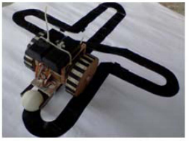

**Figure 2.1 Robot following the black line**

**2.2 Line Following Robot With Color Detection**

A line following robot is a robot that basically follows a specific line. This line following robot is sensor based. The bot was developed based on a vision-based system to navigate the robot through a black line marked in the white surface [4]. It consists of a sensor circuit which has a pair of IR Sensors. One is an IR LED as the transmitter, and another is an IR Sensor as the photoreceiver. An IR emitter will emit infrared continuously and the current received by the IR receiver is determined by the intensity of IR light received. There are 3 sensors for line detection. The middle sensor will always read black while the other two will read white surface to move forward, turn left or turn right as shown in Figure 2.2. And it is programmed to move or rotate on the basis of readings that it is getting from the readings from the sensor array. When the IR emitter falls on a white surface it gets reflected and the IR receiver receives the full IR intensity thus lower resistance between emitter and collector terminal causing flowing of current and resulting in a larger voltage. But when it falls on a black or similar surface IR is absorbed, and the receiver receives a lot less IR resulting increase resulting in a smaller output voltage.

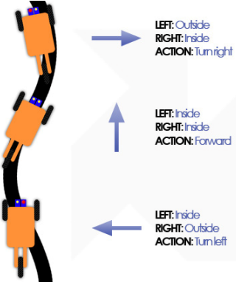

**Figure 2.2 Movement of the robot based on the sensor reading**

**2.3 Color sensor based multiple line follower robot with obstacle detection**

The system can choose a desired line among multiple lines autonomously as shown in Figure 2.3. It has a color sensor as every line has different colors as their identities. The color sensor will know sense all the color and then select the color required to it and this is done by using the servo motor in the color sensor then the motor driver (L293D) will give instruction to the motor to move the robot according to it and then it follow the color line and reaches the destination [5]. The robot senses a line and follows the desired target by correcting the wrong moves using a simple feedback mechanism but yet a very effective closed loop system. The robot can follow curves as it receives the continuous data from the sensors. The IR sensor which is present in the robot will detect the obstacle present on the path and stop the robot. The main part to move the robot is the Arduino-uno, this will control all the performance of the robot through the wireless Zigbee module. The wireless Zigbee module will transmit the signal to the Zigbee receiver. The destination which is selected by the user is received by this Zigbee module and it is given to the arduino-uno controller then this will give the required task to the color sensor (TCS230) that is given at the transmitter and transmitted through the Zigbee module.

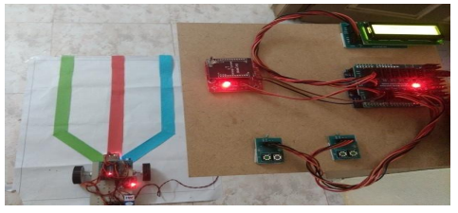

**Figure 2.3 Initial state of colour sensor based multiple line follower robot**

**2.4.** **A navigation system for the visually impaired an intelligent white cane**

The system is composed of some colored tapes that are set on a floor along the walking route. These color lines are called colored navigation lines as shown in Figure 2.4. Each color is assigned for each destination. Walking along one of these navigation lines, the user can arrive at the destination that corresponds to the color of line easily [6]. At each landmark point of the walking route, an RFID tag that indicates area code is set on a navigation line. A color sensor installed on the tip of a white cane senses the color of a navigation line. A visually impaired user swings the white cane left to right or right to left in order to find a target navigation line. If this sensor catches the target color, the white cane informs the visually impaired that he/she is walking along the correct navigation line by vibration. The white cane also makes communication with a RFID tag at the landmark point of the walking route. If the white cane finds a RFID tag, a voice processor notifies area information that corresponds to the received area code by pre-recorded voice. In this system a triaxiality acceleration sensor is installed on the white cane to detect the swing direction of a white cane by using outputs of this acceleration sensor. If the cane swings left to right, a color sensor senses red and then blue. Conversely, if the cane swings right to left, a color sensor senses blue and then red. The user's direction can be identified in order of color of the navigation line.

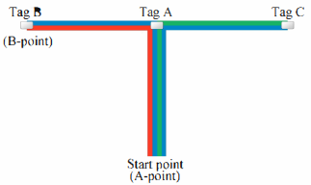

**Figure 2.4 Testing route with colored navigation lines**

**2.5. Giving Blind a Smart Eye: Designing and Modelling of Intelligent white cane for blind people**

A white cane primarily aids its user to scan their surroundings for obstacles or orientation marks. Avoiding obstacles on both the upper and lower level of the user is a challenge for the design of a white cane since it must be smarter in nature to predict accurate collision with an obstacle. A study designed an intelligent white cane where it perceives above and below knee level obstacles with its capability of tracking and signal receptor services and alerts its user from potential dangers [7]. This system detects different types of obstacles such as chains, side of a car, tree branches and even human beings and animals. The device uses an ultrasonic sensor SR-04 at the hand rest of the cane which will detect an obstacle with a maximum range of 400 cm and as the user gets closer to the obstacle, the device will alert the user in gradually increasing vibrations. The system uses angle of the sensor in which increasing the angle, increases the sensor’s capability to sense the obstacles. To draw a more accurate result, the sensing area of the sensor at the start is narrower but as the distance increases, the width of the sensing area also increases. The tracking system is composed of a four frequency GPS/GSM wireless Module that is reliable when it comes to size and functionality. The operation is based on communication with the controller using AT commands and after configuring the module, it is connected to the Arduino to initiate the commands. Comparing a normal cane and intelligent white cane, it showed on its test results 30-40% increase of helping blind people with obstacle awareness.

**2.6 Smart Walking Cane for the Visually Challenged**

The three sensors used for obstacle detection, the step sensor and the depth sensor are ultrasonic sensors. In the device, the HC-SR04 ultrasonic sensor has been used, which has a detection range of 2-400 cm and a viewing angle of 15°[8]. Three vibration motors have been attached to the hand rest of the walking cane to provide tactile feedback to the user. When an obstacle is detected by any one of the sensors, the corresponding vibration motor is activated and tells the relative location of the obstacle. It detects changes in terrain, such as steps or elevations in front of the user, presence of water, and potholes and other depressions in the ground, and sends the information to the user through voice feedback. The step sensor was placed at a height of 10 cm from the ground, and depth sensor at a height of 5 cm from the ground at an angle of 25° with respect to the walking cane to ensure an optimum range of detection. A water level sensor has been used to detect puddles in the user’s path. The sensor occupies a compact surface area of 60mm×20mm and has a detection area of 40mm×16mm. The device has been programmed to trigger a response when the water level reaches 1cm, so that false triggers are not given in the case of water droplets falling on it due to light rain. Feedback for the water detector has been given through audio commands. The audio amplifier circuit is constructed using the LM386 Audio amplifier, which can provide a gain between 20 and 200. The amplified audio is then given to a 3.5mm audio jack to be played via earphones. To reduce the weight and complexity of the device, the GSM module, rechargeable battery and the audio amplifier module have been accommodated in a separate box which can be carried in a pouch or a bag.

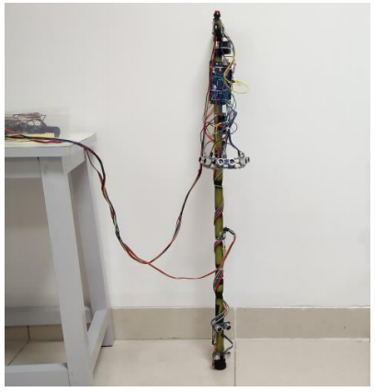

**Figure 2.5 Actual device of smart walking cane**

**2.7 Smart walking stick - an electronic approach to assist visually disabled persons**

The walking stick consists of a circuit board that contains a PIC micro controller PIC16F90 that reads the sensors, drives a buzzer, a LED and a motor with PWM [9]. Vibratory module comprises a micro pager motor which outputs is assured by PWM to obtain different vibratory patterns. The strength of the vibration of the motor or the beeping of the buzzer depends on what kind of obstacle is near the subject. The sensor-based circuitry consisting of sensors Ping Sonar Sensor, used to detect ranges from obstacles, GH311 ultrasonic obstacle sensor is applied to notice what's at the bottom of the stick such as a manhole or a large opening at the nearby bottom. A pair of electrodes at the bottom of the cane are attached to determine if the user is walking in a wet or muddy terrain.

**2.8 Smart Electronic Cane for the Assistance of Visually Impaired People**

Ultrasonic sensors can easily detect the presence of obstacles in a spacious range. Figure 2.6 shows the cane that consists of ultrasonic sensors that generate a sound pulse through a transmitter and receive the echo by receiver. Time difference between these sending and receiving sound is used to calculate distance to an object by ultrasonic sensors [10]. When an obstacle is detected by the cane, it gives warning through voice feedback. For the danger detection of the system, the Raspberry Pi camera was used to take continuous pictures of the surrounding. Then extract the feature and train the classifier to identify the respective image. Template Matching method was used for detecting danger signs (stop, danger, wet floor) in a larger image. 5 blinded subjects were subject to a testing environment with obstacles and danger symbols in 6 trials. For total 120 trials on obstacle detection by using ultrasonic sensors, the accuracy rate is 86.6% and for detecting danger signs through camera, the accuracy rate is 95% for total 60 trials. The average value of accuracy rate which is 90.93%.

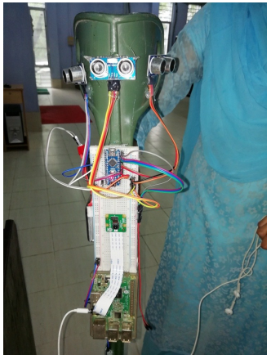

**Figure 2.6 Actual device of the smart electronic cane.**

**2.9 Vibration and Voice Operated Navigation System for Visually Impaired Person**

Blind people can’t physically hear better than others, yet blind people often outperform sighted people in hearing tasks such as locating the source of sounds. So blind people may have lost their vision, but this leaves a larger brain capacity for processing the information from other senses [11]. To alert the user, a study included in their system the implementation of a vibrational alert and voice feedback system using vibrator motor and ISD2560 ChipCorder so that the person can know the direction of the obstacle and sense its distance. It consists of ultrasonic sensors that are set up to detect the obstacles in the left, right, and front directions. A PIC 16F877A microcontroller is used to control the motor circuit to act as the warning system in which the ISD 2560 will produce a speech output. The ISD2560 IC allows multiple voice messages to be recorded and stored in 60 seconds in the different addressing modes of the IC. It will then play the recorded messages back to the user upon receiving a signal from the sensors that detects obstacles from left, right and front direction of the blind person as shown in Figure 2.7. The vibrator wraps around the wrist of the user and the voice alert is enabled when obstacles are detected.

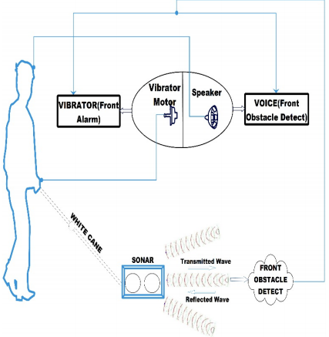

**Figure 2.7 An obstacle to the front side is detected and the vibrator vibrates.**

**2.10 Audio-based Smart White Cane for Visually Impaired People**

Nowadays, visually impaired people use a white cane as a primary tool for interaction with the environment [12]. The problem with this traditional technology is that the white cane does not give enough information about surrounding objects. Obstacle detection is integrated in the white cane using an ultrasonic sensor as shown in Figure 2.8. In order to detect the side obstacles, additional sensors are installed at the side of the cane. One of the implementations of ultrasonic sensors is detecting elevated obstacles, such as tables. The sensor outputs the difference in voltage thus the system is created in order to decode the voltage change into three types of output: no obstacle, high obstacle (stairs, wall), low obstacle (hole in the ground). The user can get a voice warning using a headset. The voice warning requires an SD card reader, SD card, and headset. The SD card is required for storing the pre-recorded warning audio files. The SD card reader is required for reading data from the SD card. When the sensors’ reading does not match with the reading from the flat ground, the system will alert the user by the audio signal.

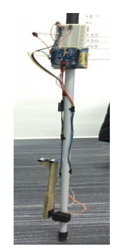

**Figure 2.8 Actual prototype of the audio-based white cane**

**2.11** **Design and Testing of a Practical Smart Walking Cane for the Visually Impaired**

The cane detects the presence of the object and how near it would be using two ultrasonic sensors, HC-SR04, then informs the user to change his/her position with a clear vocal warning using a wireless headset [13]. Those sensors produce sound waves above the frequency of human hearing and can be used in several different applications such as proximity detection and movement detection. A GPS system mounted on the stick helps the user go anywhere by following directions stored in the GPS’s database system. The GPS tracker is embedded along with the GSM module to send the cane’s GPS coordinates to a pre-saved phone number. When the user seeks emergency and does not know his/her exact location, using a wireless microphone, the user can say a simple voice command "Call", and the cane would generate a call to the pre-saved phone number. On receiving the cane’s GPS coordinates, the authorized person will be able to detect the cane’s location, and therefore rescue the user. The user can also use the command word "Location”, which enables the cane to send its current location to the pre-saved phone number in the form of a URL, within a text message, that opens in the Google Maps application. Lastly, the authorized person may initiate a call to the cane. The GPS tracker of the cane returns the current location. The smart cane includes a voice recognition module called  EasyVR, which works with the GSM module and includes a SIM card to connect to a cellular network.

**2.12 Braille Keyboard for People with Low Vision**

The Braille alphabet is a writing system created by Louis Braille in the year 1825 for people with impaired vision [14]. The letters of this system consist of a cell with 6 embossed points (consisting of 2 columns and 3 rows), and each cell representing a normal alphabet letter. A study designed a keyboard that can be connected to any computer, phone or tablet via cable. The keyboard will have twelve buttons, six of them are predefined, and the other 6 form the Braille language cell. For the Braille cell, 2 flexible type 1 x 4 keys have been used, each key being connected separately to its port, without using matrix keyboards or string type as shown in Figure 2.9. In order to create the Braille cell, an association of a binary number with values between 0 and 63 is made, each key corresponding to a value. For button 1, the value 1 was allocated for button 2, the value 2 was allocated for button 3, the value 4 was allocated, and for the remaining 3 buttons, values 8, 16 and 32, such as the binary code, were allocated in order.

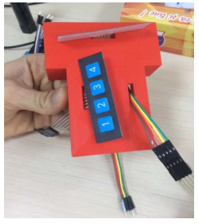

**Figure 2.9 Location of keyboards in position**

**2.13** **Braille Assistance System for Visually Impaired, Blind & Deaf-Mute people in Indoor & Outdoor Application**

Another study developed a device to assist the blind in moving safely indoor or outdoor [15]. It proposes a system that uses Arm microcontroller and IR sensors for obstacles and for holes detection. The moisture sensor for ponds detection process, fire/smoke sensor for detection of fire/smoke and vibrator motor were also used for alerting the blind. In the obstacle detection process, the device checks if there is any obstacle in front of the user within the range of less than 10m. Braille keypad is also implemented in the system as it is the main source of visually impaired people for reading and studying. It contains a panic button to inform his caretaker or guardian in case of emergencies. An SMS is sent to them with the link containing the user’s location, for different emergencies such as personal and medical assistance are said to be integrated for different Braille numbers. Additionally, to display caretaker’s number, a Braille switch is incorporated. If the blind person misses his path then the location of the corresponding person will be sent to their caretakers through the GPS module.

**CHAPTER 3**

**DESIGN PROCEDURES**

This chapter provides the step-by-step procedures for the design process flow, hardware development and the software development. This chapter will discuss how the system was designed and develop.

1. **Design Process Flow**

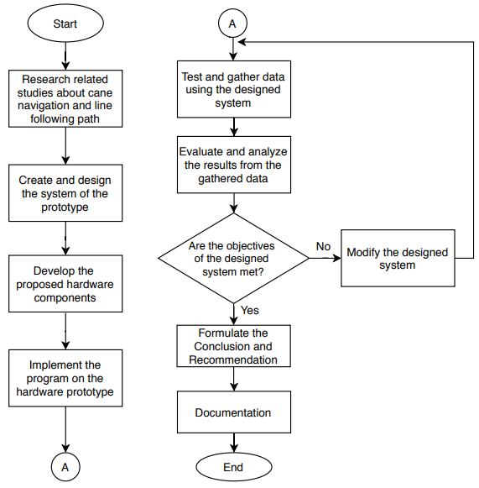

**Figure 3.1 Design Process Flowchart**

In Figure 3.1. It shows the step-by-step design development procedure. First, to design a system, it is important to research studies related to cane navigation and line following path. With all the gathered information based on the previous studies, it can help to design a better and improved system. The group will then proceed to the hardware and software development of the system. Testing of the design will be conducted to verify the prototype’s functionality. The results will be gathered, and the researchers will proceed to the interpretation of results then formulate a conclusion.

1. **Hardware Development**

The following steps are the procedures followed in developing the hardware of the designed system.

1. A Design Process Flowchart was created to develop the procedures of the system to determine the flow of the designed system.
2. A conceptual framework was created to identify the design’s input, the process and the output.
3. The components needed to develop the designed system were identified and illustrated using the hardware block diagram.
4. Schematic diagram of the main circuit was created based on the hardware block diagram.
5. An Isometric Diagram of the designed system was developed in order to see what the system will look like and how the casing will be created.
6. **Conceptual Framework**

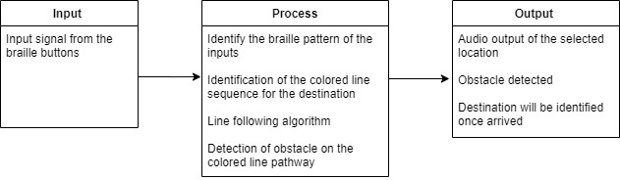

**Figure 3.2 Conceptual Framework**

The system will require the user to input the desired location using braille buttons on the device. The microcontroller will process the braille button inputs which will form the equivalent location on the device. The system will analyze which algorithm is going to be used to detect and follow the colored line assigned to each location. As the user is following the colored line, the device will keep the user on track and detect if there is an obstacle 1m away from the user with the use of the ultrasonic sensor. Voice output will indicate if there is an obstacle along the path and if the user has arrived at the target destination.

1. **Block Diagram**

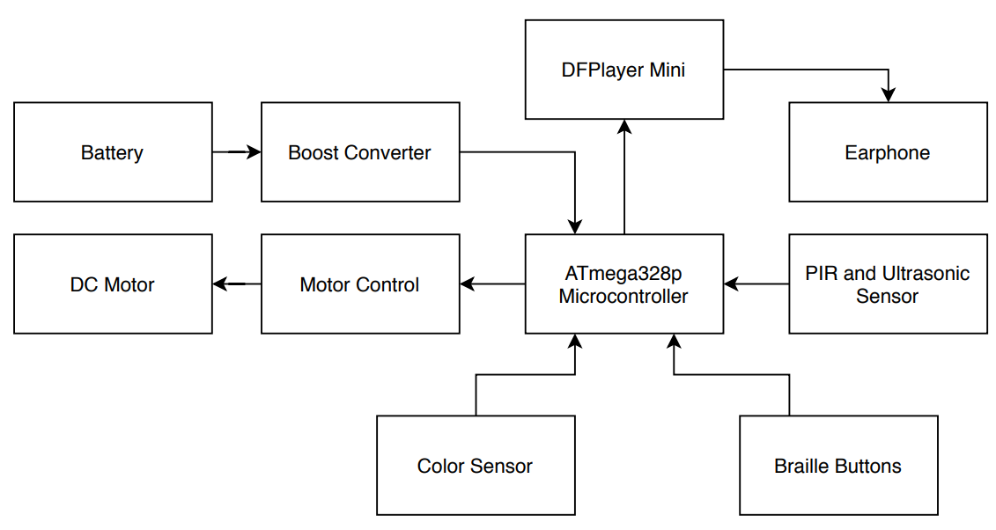

**Figure 3.3 Hardware Block Diagram**

Figure 3.3 shows the hardware block diagram of the designed prototype. The cane is functioning using a 3.7V Li-ion rechargeable battery step up to 5V to power up the ATmega328p microcontroller. There are designated braille buttons for each target location and it will be processed by the ATmega328p. The color sensors are used to detect the correct colored line based on the braille inputs, while the DC motor is used to keep track of the user’s direction and movement towards the target location. The PIR and Ultrasonic sensors detect the surrounding area for any obstacle and the data gathered would be sent to the ATmega for processing. The DFPlayer mini player would be activated to output pre-loaded voice.

1. **Schematic Diagram**

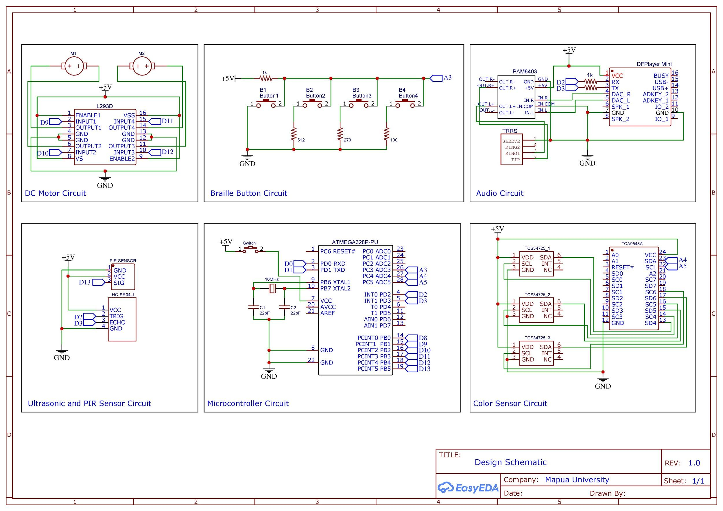

**Figure 3.4 Schematic Diagram**

Fig 3.4 shows the schematic diagram of the whole system. The schematic diagram was created using the software EasyEDA. The ATmega is powered by a two 3.7 V battery that was connected to a step-down circuit to make the voltage 5v from 7.4v. There are 2 22pF capacitors connected to the crystal oscillator that provides stability. A crystal oscillator is connected to two digital pins of the ATmega328p to provide clock pulse. The clock pulse is needed for the synchronization between the ATmega chip and the device that is connected to it. The switch is for turning on and off the device.

4 buttons are connected to the analog pin of the ATmega. In order to prevent the circuit from directly connecting +5v to Ground, pull up or pull-down resistors are used. These resistors are connected in the input and output terminals of the device. The 4 buttons will serve as the braille button inputs and will signal the microcontroller to which location is to be followed.

Three TCS34725 RGB color sensors are connected to the 3 I2C buses of the TCA9548a multiplexer and a single bus to be connected to 2 analog pins of the ATmega chip, which will transmit variable signals instead of just low or high signals. This gives the microcontroller control on the 3 color sensors. The signals will then be sent to the microcontroller so that the motor can determine which way to go or to know if it is still on the right track.

An ultrasonic Sr-04 avoidance sensor and PIR sensor are connected to the digital pins of the ATmega to send sound waves which will be reflected back to the sensor to determine if an obstacle is near. If an object is detected, the microcontroller will then signal the motor to stop running. There are two motors that are connected to the digital pins of the ATmega.

The L293D acts as an interface between the microcontroller and motor 1 and motor 2. The L293D is a 16-pin Motor Driver IC which can control a set of two DC motors simultaneously in any direction. The direction of these two motors can be controlled independently. The L293D is designed to provide bidirectional drive currents of up to 600 mA at voltages from 4.5 V to 36 V. The enable pins are used to enable input pins for motor 1 and motor 2. The input pins Input 1, 2 are used to control the motor 1 and Input pins 3, 4 are used to control the motor 2. The input pins are connected to the ATmega to control the speed and direction of the motor. Output pins 1,2 are connected to the terminals of the motor 1 and output pins 3,4 are connected to the terminals of motor 2.

The mp3 module DFPlayer Mini is connected to the 2 digital pins of the ATmega chip to receive serial commands. This will be used to load the voice output that was stored in the voice recognition module. The module comes with an SD card slot and it is connected to the input pins of the mini PAM8403 sound amplifier. The right and left output pins of the PAM8403 sound amplifier are connected to the signal and ground pins of the TRRS audio jack. The TRRS cable includes both a left and right channel as well as a microphone channel. The earphones connected will be signalled by the microcontroller to output the stored messages in the module.

1. **Isometric Diagram**

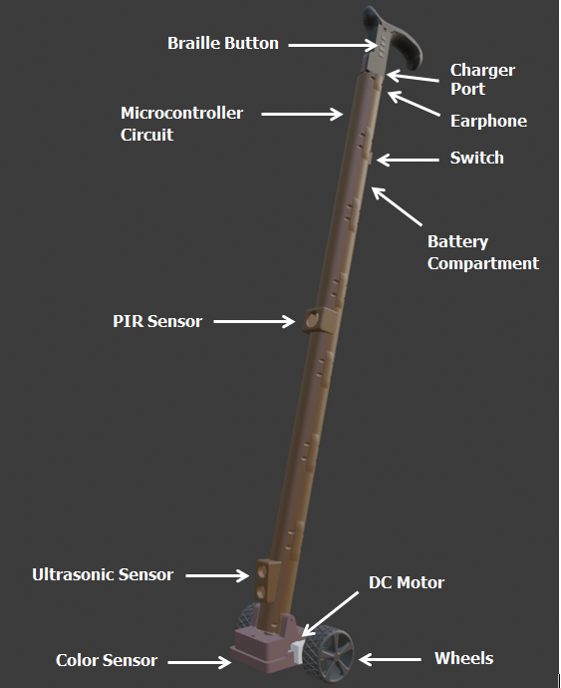

**Figure 3.5 Isometric Diagram**

1. **Software Development**

The following steps are the procedures followed for the software development of the designed system.

1. Construct flowcharts of the program to show the flow and determine the input process and the expected output of the designed prototype.
2. Develop the program for the colored line navigation of the designed prototype by following the program flowcharts.

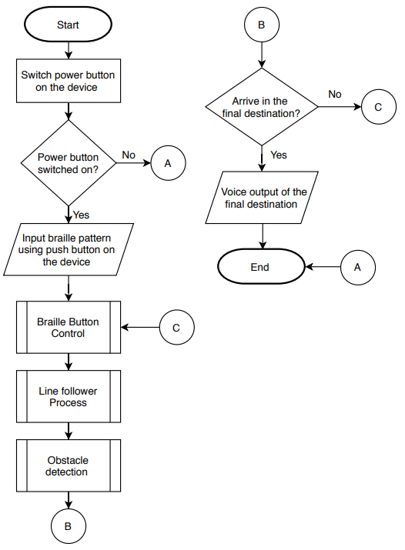

**Figure 3.6 Main Flowchart of the Program**

The Dual-Wheeled cane flowchart starts with the users switching a button that will turn on the device. The user must then input its desired location through the braille buttons on the device. It will then proceed in following the colored line corresponding to the location recognized by the system from the braille input of the user. When the system is turned on, it will continuously sense for obstacles in the direction of the colored line. While on the track, the device will check if the user has reached the final location, if not, it will go back to initializing the correct colored line to be followed.

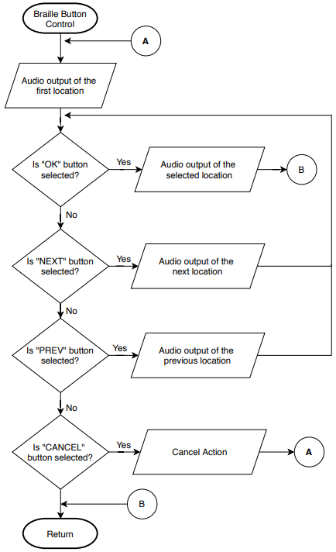

**Figure 3.7 Flowchart of Braille Button Control**

The figure shows the braille button control of the system. It starts with the user listening to the audio about the first location. If the user pressed the first or “OK” button, the audio about the selected location will be heard. Else, if the user pressed the second or “Next” button, the audio about the next location will be heard by the user. The user can then press the first or “OK” button if he/she wants to proceed. Else, if the user pressed the third or ”Prev” button, the audio about the previous location will be heard by the user. The user can then select the first button if he/she wants to proceed. The audio about the selected location will be heard. Else, if the user pressed the fourth or “Cancel” button, the system will return to playing the audio about the first location.

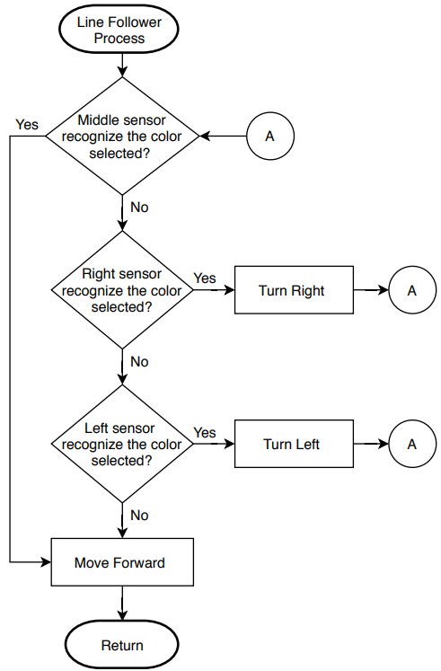

**Figure 3.8 Flowchart of Line Follower Process**

For the destined colored line to be followed by the system, the system will start by choosing which sensor on the cane recognizes the color inputted by the user. If the sensor on the right of the cane senses the color, the device will prompt the user to turn right, otherwise, if the sensor on the left the cane senses the color, the device will prompt the user to turn right. When the middle sensor senses the color, it will continue on the following path.

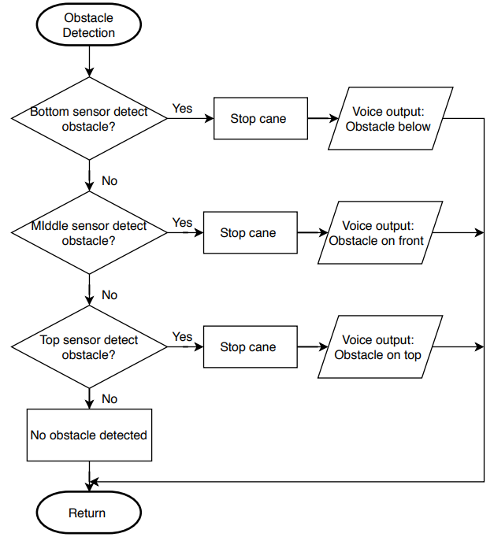

**Figure 3.9 Flowchart of Obstacle Detection Function**

For obstacle detection, to cover all the objects around the stick, the sensors are mounted on top, middle and bottom of the stick with the correct angle. It is necessary to test all the probable areas to place the sensors. If there is an obstacle, a speech output corresponding to the position of the sensor will turn on notifying the user by speech notification. The device will then stop if an obstacle is detected.

1. **Prototype Development**
2. **PCB Design**

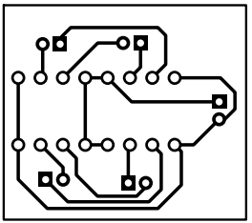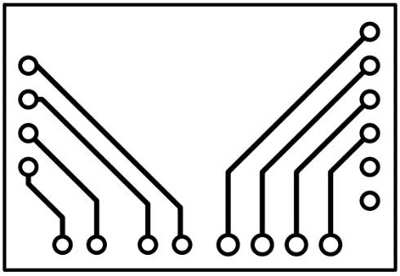

**Figure 3.10.1 DC Motor Printed Circuit Board Design**

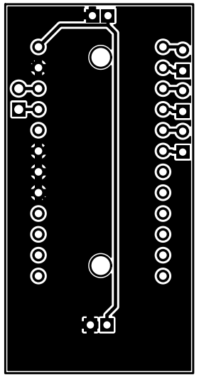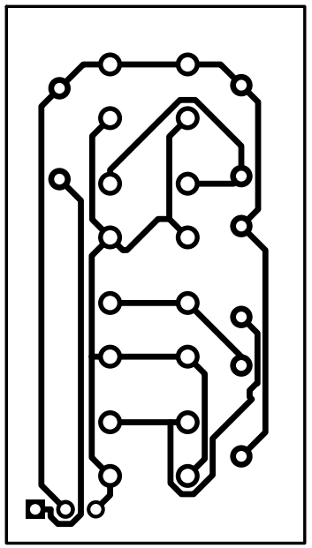

**Figure 3.10.2 Multiplexer with Color Sensor (Left) and**

**Braille Button Control (Right) Printed Circuit Board Design**

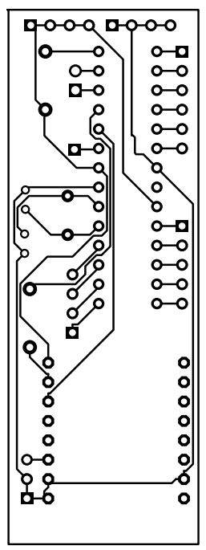

**Figure 3.10.3 ATMEGA328P and Audio Circuit PCB Design**

The design prototype has four (4) PCB designs inside the 3D printed cane. Each PCB has a separate function to others. The figures show the PCB design for DC motor, multiplexer with color sensor circuit, braille button control and ATmega328p together with the audio circuit. The following PCB are divided into smaller boards in order to fit inside the cane. There is no PCB design used for the Ultrasonic and PIR sensor because they are directly connected to the ATmega328P board using connecting wires.

The EasyEDA software was used to create the layout with a 0.025’’ trace width enough to allow voltage/current to pass through each component in the circuit board.

1. **PCB Component**

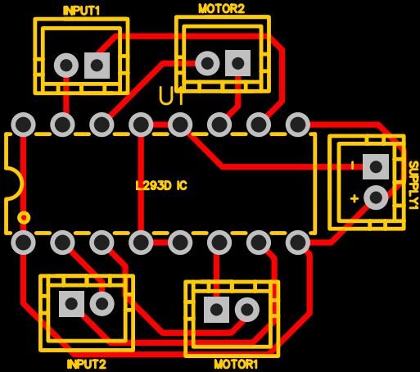 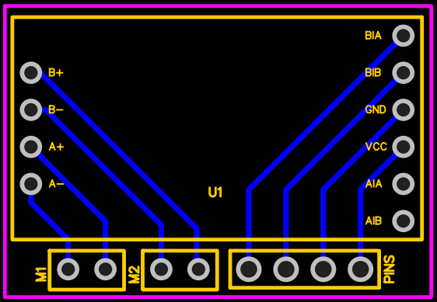

**Figure 3.11.1 DC Motor Printed Circuit Board Component**

The figure shows the various components used in the DC motor of the designed prototype. The dimension for the board of the DC motor is 1.080” x 0.955”.

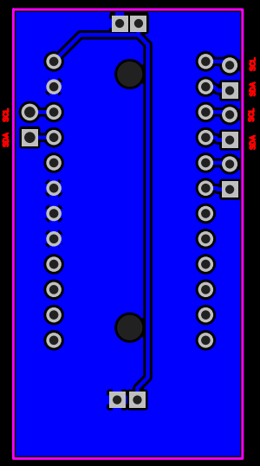 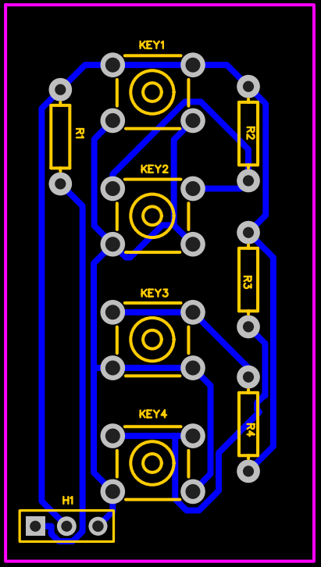

**Figure 3.11.2 Multiplexer with Color Sensor (Left) and Braille Button Control (Right) Printed Circuit Board Component**

The figure shows the components used in the multiplexer with color sensor and braille button circuit of the designed prototype. The dimension for the board of the multiplexer with color sensor circuit is 1.775” x 0.9” while the Braille button control dimension is 1.775” x 0.9”.

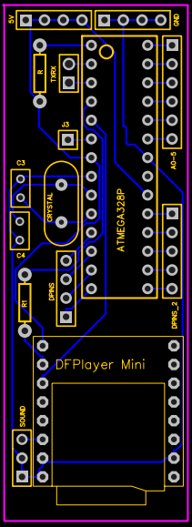

**Figure 3.11.3 ATMEGA328P with Audio Circuit PCB Component**

The figure shows the components used in the ATMEGA328p with Audio Circuit. The dimension for the board is 2.760” x 0.975”. The other PCB board will be connected to the ATmega328p board using connectors.

1. **Casing Model of the Prototype**

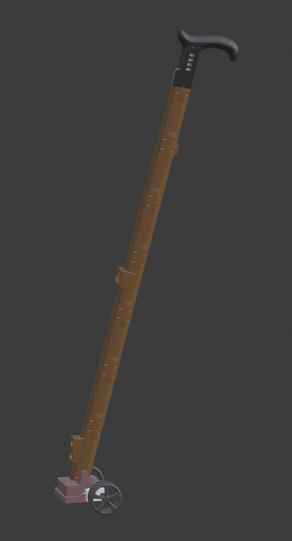

**Figure 3.12.1 3D casing models for designed prototype**

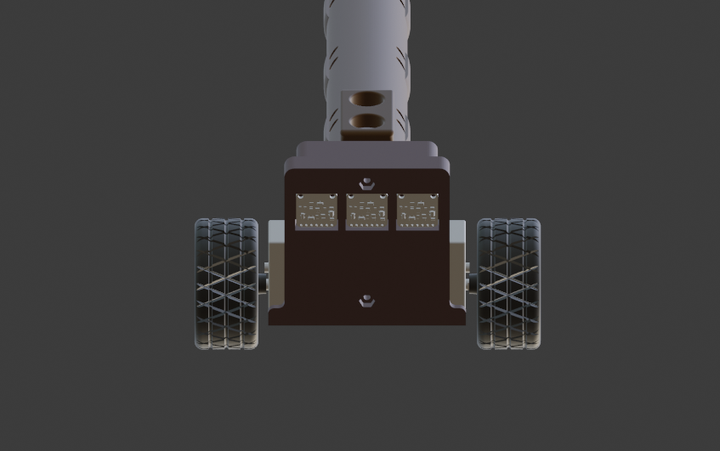

**Figure 3.12.2 Color Sensor 3D Casing**

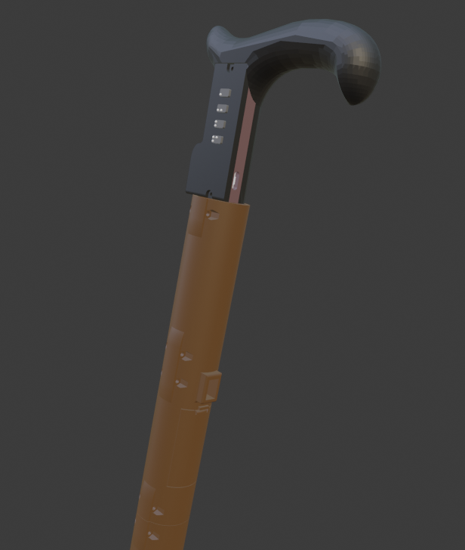 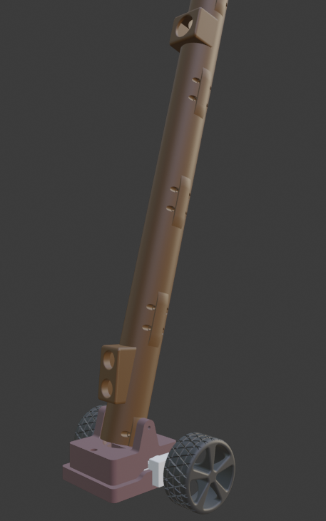

**Figure 3.12.3 3D casing models for designed prototype**

1. **Bill of Materials**

|  |  |  |  |
| --- | --- | --- | --- |
| **Item Name** | **Quantity** | **Unit Price** | **Subtotal** |
| ATMega328p | 1 | 110.00 | 110.00 |
| 16Mhz Crystal Oscillator | 1 | 11.00 | 11.00 |
| Ceramic Capacitors | 2 | 2.00 | 4.00 |
| Multiplexer | 1 | 85.00 | 85.00 |
| TCS3427 Color Sensor | 3 | 150.00 | 450.00 |
| L293D IC | 1 | 40.00 | 40.00 |
| 6V DC Motor | 2 | 80.00 | 160.00 |
| Ultrasonic Sensor SR-04 | 1 | 40.00 | 40.00 |
| PIR Sensor | 1 | 70.00 | 70.00 |
| DF Mini Player MP3 | 1 | 100.00 | 100.00 |
| Resistor - 1/4W 1k | 3 | 0.25 | 0.75 |
| Resistor - 1/4W 100 ohms | 1 | 0.25 | 0.25 |
| Resistor - 1/4W 270 ohms | 1 | 0.25 | 0.25 |
| Resistor - 1/4W 512 ohms | 1 | 0.25 | 0.25 |
| Rocker Switch | 1 | 15.00 | 15.00 |
| 5V Boost Converter | 1 | 70.00 | 70.00 |
| Push Button | 4 | 5.00 | 20.00 |
| Colored Tapes (6pcs) | 1 | 230.00 | 230.00 |
| 3D Filament | 1 | 600 | 600 |
| Total |  |  |  |

Table 3.1 shows the list of components and materials used to develop the prototype. Apart from ensuring the reliability of the prototype in performing its intended functions, the components above were chosen for their economic cost, thus keeping the overall amount of money used to develop the prototype to a minimum.

1. **Multiple Design Constraints**

|  |  |  |  |  |  |  |  |
| --- | --- | --- | --- | --- | --- | --- | --- |
| **DECISION EVALUATION CRITERIA** | | | | | | | |
| Scale: 1 = lowest weighting/alignment w/ criteria  5 = highest weighting/alignment w/ criteria | | | | | | | |
|  | Operation Time | | Braille Pattern Representation | | Output Quality | | Total |
| **Weight** | 0.2 | | 0.4 | | 0.4 | | 1 |
| **Design Constraints** | Score | Weight | Score | Weight | Score | Weight | Total |
| Economical Cost | 2 | 0.6 | 2 | 0.6 | 3 | 1.2 | 2.4 |
| Aesthetics | 3 | 0.9 | 1 | 0.3 | 4 | 1.6 | 2.8 |
| Quality | 5 | 1.5 | 3 | 0.9 | 5 | 2 | 4.4 |
| Constructability | 2 | 0.6 | 5 | 1.5 | 3 | 1.2 | 3.3 |
| Health and Safety | 2 | 0.6 | 2 | 0.6 | 3 | 1.2 | 2.4 |
| Ethical | 2 | 0.6 | 1 | 0.3 | 2 | 0.8 | 1.7 |
| Environmental | 1 | 0.3 | 1 | 0.3 | 2 | 0.8 | 1.4 |

**Table 3.2 Multiple Constraints Decision Matrix**

Table 3.2 shows the scoring of the design constraint per criterion.  The criteria are given a grade based on their contribution to the constraints. The three constraints that got the highest scores were given solutions. The highlighted rows on the table, constructability, quality, and manufacturability constraints are the design constraints that greatly affected the design of the device therefore alternative solutions are identified to solve these constraints.

**Constructability**

The design prototype must be safely used by the user. The blind may have difficulty using the device if the components are expired and the wirings may be pulled, resulting in malfunction. The option that we can implement for the system is to construct it by embedding the components inside a 3D printed cane or place the components inside a polycase/plastic electronic enclosure.

**Quality**

The system must accurately navigate the user with certainty. The solution must be able to provide precise directions to prevent prolonged navigation and confusion for the user. The options that we can implement for the system to achieve this feature is the use of a colored-line path or IC tags.

**Manufacturability**

Manufacturability became a major design constraint for the creation of the system since initially, the researchers had to implement their system using a presensitized PCB (Printed Circuit Board). But again, due to the global pandemic, several steps in making a PCB became a constraint, such as: printing the PCB design, exposing the board to Ultraviolet light; etching the board, cleaning the board, laminating the PCB layers, and drilling the PCB. The researchers must think of another way to implement their system.

1. **Trade-offs**

**Constructability**

To achieve safety for the user, we had to find a way to build a cane that can support all the components whilst being constructable for the user and other people. We decided to use 3D printing in building the cane as the components can be embedded inside providing over-all safety for both the device and the user.

**Quality**

To accurately navigate the user with certainty, we had to find other technologies to implement on our design that will guide the user towards the target location without difficulty and confusion. We decided to use colored-line paths while using the dual-wheeled cane to achieve the design needs.

**Constructibility**

The researchers must create a presensitized PCB for their circuit. But again, due to the global pandemic, the steps needed for creating a presensitized PCB are not accessible. The researchers must choose another way of implementing their circuit other than using a presensitized PCB.

1. **Selection of Alternative Solution**

**Table 3.3 Decision Matrix for Quality Constraint**

|  |  |  |  |  |  |
| --- | --- | --- | --- | --- | --- |
| Quality Constraint | Weight | Alternative Solution | | | |
| Line Path | | IC Tags | |
| Score | Weighted Score | Score | Weighted Score |
| Certainty of Destination | 0.6 | 5 | 3 | 1 | 0.6 |
| Directness/Directness of Action | 0.4 | 4 | 1.6 | 5 | 2 |
| Total weighted Score | | **4.6** | | 2.6 | |

Table 3.3 shows the decision matrix for the quality constraint. The quality constraint needed to overcome is the need for the device to navigate the user with certainty. The main factors considered by the group for the quality constraint are confidence and directness of the device. Two solutions were formulated, which is the use of a colored-line path or the use of location tags. Certainty of destination refers to how the user will confidently go to the location without feeling lost. Directness refers to how the device directly and swiftly leads the user to the target location. Location tags can only tell the user that they arrived at the location but do not directly lead the user to the location, on the other hand, the colored-line path directly leads the user to the target location without losing its trail on its way. After giving scores to both solutions based on the needs of the design, the colored-line path was chosen with a score of 4.6, which provides better quality of output, compared to the location tags with a score of 2.6, which gives less confidence and not much directness.

**Table 3.4 Decision Matrix for Manufacturability Constraint**

|  |  |  |  |  |  |
| --- | --- | --- | --- | --- | --- |
| Aesthetics  Constraint | Weight | Alternative Solution | | | |
| 3D printed casing | | Plastic enclosure | |
| Score | Weighted Score | Score | Weighted Score |
| Availability of the material | 0.4 | 3 | 1.2 | 4 | 1.6 |
| Durability | 0.6 | 5 | 3 | 3 | 1.8 |
| Total weighted Score | | **4.2** | | 3.4 | |

Table 3.4 shows the decision matrix for the manufacturability constraint. The manufacturability constraint needed to overcome is the need for the user to be safe while using the device. The main factors considered by the group are the availability and the durability of the device. Two solutions were formulated, which is the use of 3D print in building the casing of the components of the device, or the use of plastic enclosure. The availability is based on whether the material is available in the market. The durability criteria refer to how stable and secure the material is going to hold the components all together. Since the device is going to be used by a blind person, it is important that the device can be used anytime without technical malfunctioning. After giving scores to both solutions based from the needs of the designed system, the use of a 3D print was chosen with a score of 4.2, which is available in the market and give better durability for the device, compared to the plastic enclosure with a score of 3.4, which is available in the market as well, but it would result in less durability.

**Table 3.4 Decision Matrix for Constructability Constraint**

|  |  |  |  |  |  |
| --- | --- | --- | --- | --- | --- |
| Constructability  Constraint | Weight | Alternative Solution | | | |
| Universal PCB | | Presensitized PCB | |
| Score | Weighted Score | Score | Weighted Score |
| Availability | 0.5 | 5 | 2.5 | 3 | 1.5 |
| Flexibility | 0.5 | 4 | 2 | 5 | 2.5 |
| Total weighted Score | | **4.5** | | 4.0 | |

Table 3.5 shows the decision matrix for the constructability constraint. Two solutions were formulated to solve the constructability constraint, which is to use a presensitized PCB or universal PCB. The main factors considered by the group are the availability and flexibility of the PCB to be used for the device. The presensitized PCB will give flexibility for the circuit of the device since the circuit connections had already been made or the use of universal PCB that provides availability since the researchers already had multiple universal PCBs at home. Due to the global pandemic, accessibility was given a higher weight and it will be the deciding factor for the solution to be implemented. After giving scores to both solutions based from the needs of the designed system, the use of a universal PCB was chosen with a score of 4.5, which gives priority to the availability for the device, compared to the presensitized PCB with a score of 4.0, which gives priority to the flexibility for the device instead of its availability.

1. **Impact of Design solution**

The design can impact the way of living of the blind. The blind always wanted to be independent, but with the lack of vision, they would sometimes get the objects around them. With the help of the device, it would be safer and easier in navigating their environment because they will now be able to detect obstacles at body or head level. Other ways the design can make an impact are the following:

* Timewise, the ordinary cane makes the blind identity obstacles at the same time, navigate towards the location in slow pace. The designed system is faster and easier because it will directly lead the blind to its desired location.
* Societal, blind people are dependent on the guidance of others, but the truth is they can also be independent individuals.  All they need is the proper training and education with the assistance of tools that solve problems that are out of their control. Giving blind people tools such as this design solution can give normal people the idea that these people are capable of being independent too.

1. **Engineering Principles**

To build a device that can easily and safely navigate a visually impaired person towards a location, engineering principles were applied.

* Electrical

Basic electrical principles were used to determine the right resistor values for the motor and buttons to be connected to the 5v to the ground. The amount of resistance required was determined based on the circuity of the motor.

* Electronics

Basic electronic principles are used to make the device work properly especially in the connection of connection of the components and the operation of the transistors to allow the functionality of the motors of the device.

* Programming

Programming is used to program the microcontroller, which includes gathering of sensor readings, determining the output based on the readings, and enabling the right parts to produce the expected output of the device.

1. **Modern Engineering Tools**

* Arduino IDE

The Arduino IDE is used to program the instructions for the ATmega328 and how it would respond to the different readings gathered from the sensor. It is also used for debugging purposes by using the serial monitor to see the actual reading of the sensor and calibrate it to get the reading the device needed.

* Blender

The Blender is a software that provides tools for architectural, engineering, and 3D modeling design. This is the software tool used to develop the 3D model of the device’s case.

* EasyEDA

The EasyEDA is a software program that provides various tools in creating the schematics of the circuit. This is the software used in creating the schematic diagram of the device. This also allows the user to create a PCB design. This is the software used to create the PCB design of the device.

**CHAPTER 4**

**TESTING, PRESENTATION, AND INTERPRETATION OF DATA**

1. **Accuracy Testing of the Device**

An accuracy test was performed to verify that the device can safely lead the user in an indoor environment. The device will be used by 3 blind folded subjects in an indoor testing route. There are 3 target locations set on the floor and along the pathway, obstacles will be set up. There are 3 trials for each subject, meaning they must pass the testing route 5 times.

1. **Purpose of the Test**

These tests are performed to check the effectiveness and accuracy of the device in safely navigating towards the target location, using the color sensors, and the obstacle sensors.

1. **Initial Assumptions**

Before testing the device, the following assumptions are to be expected:

* The battery of the device is completely charged
* There colored-navigation lines had been setup
* There are no obstacles during Test No. 1
* There are obstacles set up during Test No. 2

1. **Complete Procedures to be followed in conducting the Test**

Test No. 1

1. Place the cane in the starting point of the testing route see Figure 4.1.
2. Check whether the device detects the colors on the line path.
3. As the cane moves, check whether the cane follows the correct colored-line of the target location.
4. Check whether the cane has arrived at the correct target location.

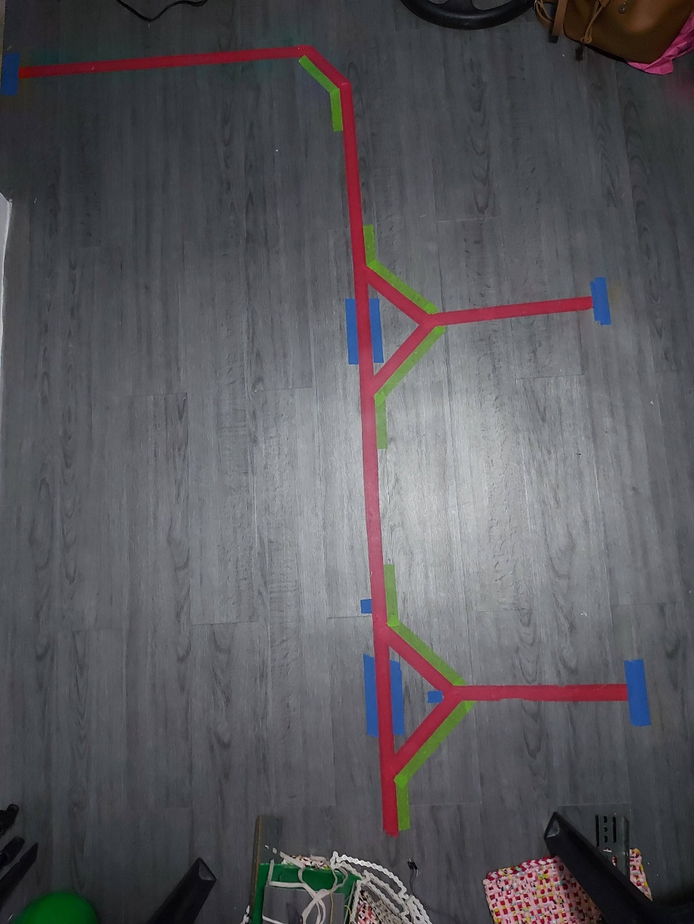

Room C

Room B

Room A

**Figure 4.1 Testing route consisting of colored-navigation lines**

Test No. 2

1. Place the cane in the starting point of the testing route.
2. While moving, place an obstacle on the testing route.
3. Check whether the sensor detects that there is something in its proximity.
4. As the cane moves, check whether the sensor detects that the obstacle is getting near.
5. Lastly, check if the cane stops when the obstacle is about 240 cm.
6. **Table of data collected in the test**

**Table 4.1. Tabulated Results of the Navigation Test**

|  |  |  |  |
| --- | --- | --- | --- |
| **Trial** | **Current Location** | **Target Location** | **Remark** |
| 1 | Room A | Room B | Arrived at room B; device stops |
| 2 | Room B | Room C | Arrived at room C; device stops |
| 3 | Room A | Room C | Arrived at room C; device stops |
| 4 | Room B | Room A | Arrived at room A; device stops |
| 5 | Room C | Room A | Arrived at room A; device stops |
| 6 | Room C | Room B | Arrived at room B; device stops |

**Table 4.2. Tabulated Results of Obstacle Detection**

|  |  |  |  |
| --- | --- | --- | --- |
| **Distance from the Obstacle** | **PIR sensor** | **Ultrasonic sensor** | **Remarks** |
| <240 cm | 🗸 | 🗸 | Obstacle detected; device stops |
| <240 cm | 🗴 | 🗸 | Obstacle detected; device stops |
| <240 cm | 🗴 | 🗸 | Obstacle detected; device stops |
| <240 cm | 🗸 | 🗴 | Obstacle detected; device stops |

1. **Analysis and Interpretation**

Table 4.1 shows the tabulated results of navigation and color detection using the sensors in the device. There would be five results in testing whether the device arrives in the target location without any delay.  Based on the results, it shows that it correctly leads the user to the target room. Once the user arrives at the target location, the device will stop, the user can then set the next target location.

Table 4.2 shows the tabulated results of the obstacle detection sensor of the device. There are two ultrasonic sensors in which the device could detect if there is an obstacle, one is placed on the middle part of the cane to detect taller obstacles and the second sensor is placed on the lower part of the cane to detect shorter obstacles. Both sensors are set to detect obstacles within 1m distance. Based on the results, it shows that when there is an obstacle within 1m from the device, the device stops, meaning, the sensor correctly identifies that there is an obstacle. This will then trigger the device to stop and notify the user that there is an obstacle ahead.

**CHAPTER 5**

**CONCLUSION AND RECOMMENDATION**

**Conclusion**

The 2-wheeled cane was specifically designed to aid the blind students of the Philippine National School for the Blind in strolling in their school indoor hall. The device was built to give solutions to blind individuals to be able to navigate their way from one place to another in a safer and faster way. Thus, it can be stated that the researchers were able to create a circuit and develop a program that can automatically follow the colored-line tracks and detect obstacles. Also, the group was able to notify the user when there is an obstacle and when he/she has arrived at the target location through an output pre-recorded voice. Based on the tests conducted, the wheeled cane detects and moves accordingly.

**Recommendation**

To further improve the design project, the researchers recommend using a bigger voltage of battery to prolong the usage time of the cane. Developing a device with similar features with the use of mobile application could be a possible for improving the way the user interacts with the cane.

**References**

[1] "Public Told: Protect your Eyes from Blindness," 2017.

[2] C. Willings, "Mobility Skills," in Teaching Students with Visual Impairments, 2019.

[3] K. M. Hasan, A. AI-Nahid and A. Al Mamun, "Implementation Of Autonomous Line Follower Robot," IEEE/OSA/IAPR International Conference on Informatics, Electronics & Vision , pp. 865-869, 2012.

[4] M. R. Abedin, F. Alam and A. M. Dip, "Line Following Robot With Color Detection".

[5] "Color sensor based multiple line follower robot with obstacle," 2015.

[6] A. J. Fukasawa and K. Magatani, "A navigation system for the visually impaired an intelligent white," 34th Annual International Conference of the IEEE EMBS, pp. 4760-4763, 2012.

[7] M. H. Daudpota, A. A. Sahito, A. M. Soomro and F. S. Channar, "Giving Blind a Smart Eye: Designing and Modelling of Intelligent white cane for blind people," 2017.

[8] S. Salat, Habib and M. Ashfak, "Smart Electronic Cane for the Assistance of Visually Impaired People," in 2019 5th IEEE International WIE Conference on Electrical and Computer Engineering (WIECON=ECE), Bangladesh, 2019.

[9] N. Mahmud, R. Saha, R. Zafar, M. Bhuian and S. Sarwar, "Vibration and Voice Operated Navigation System for Visually Impaired Person," in 3rd Internation Conference on Informatics, Electronics & Vision 2014, Bangladesh , 2014.

[10] D. Zhangaskanov, N. Zhumatay and M. H. Ali, "Audio-based Smart White Cane for Visually Impaired People," in 2019 5th International Conference on Control, Automation and Robotics, 2019.

[11] N. M. Obaid, I. A. Hamad, A. M. Madkhane and Y. A. Hamad, "Design and Testing of a Practical Smart Walking Cane for the Visually Impaired," 2019 IEEE/ACS 16th International Conference on Computer Systems and Applications (AICCSA), pp. 1-5, 2019.

[12] V. H. Sirbu, I. Serban and I. C. Rosca, "Braille Keyboard for People with Low Vision," in The 7th IEEE International Conference on E-Health and Bioengineering - EHB 2019 , 2019.

[13] S. Kumar KN, R. Sathish, S. Vinayak and T. Parasad Pandit, "Braille Assistance System for Visually Impaired, Blind & Deaf-Mute people in Indoor & Outdoor Application," in 4th International Conference on Recent Trends on Electronics, Information, Communication & Technology (RTEICT-2019), 2019.

[14] M. H. Mahmud, R. Saha and S. Islam, "Smart walking stick - an electronic approach to," International Journal of Scientific & Engineering Research, vol. 4, no. 10, pp. 111-114, 2013.

[15] G. A. Mutiara, G. I. Hapsari and R. Rijalul, "Smart Guide Extension for Blind Cane," 2016 Fourth International Conference on Information and Communication Technologies, pp. 1-6, 2016.

[16] S. Murali, R. Shrivatsan, V. Sreenivas, S. Vijjappu, J. Gladwin and R. Rajavel, "Smart Walking Cane for the Visually Challenged," in 2016 IEEE Region 10 Humanitarian Technology Conference (R10-HTC), 2016.

**Appendix A: IEEE Article**

**Appendix B: Operations Manual**

**Device Parts**

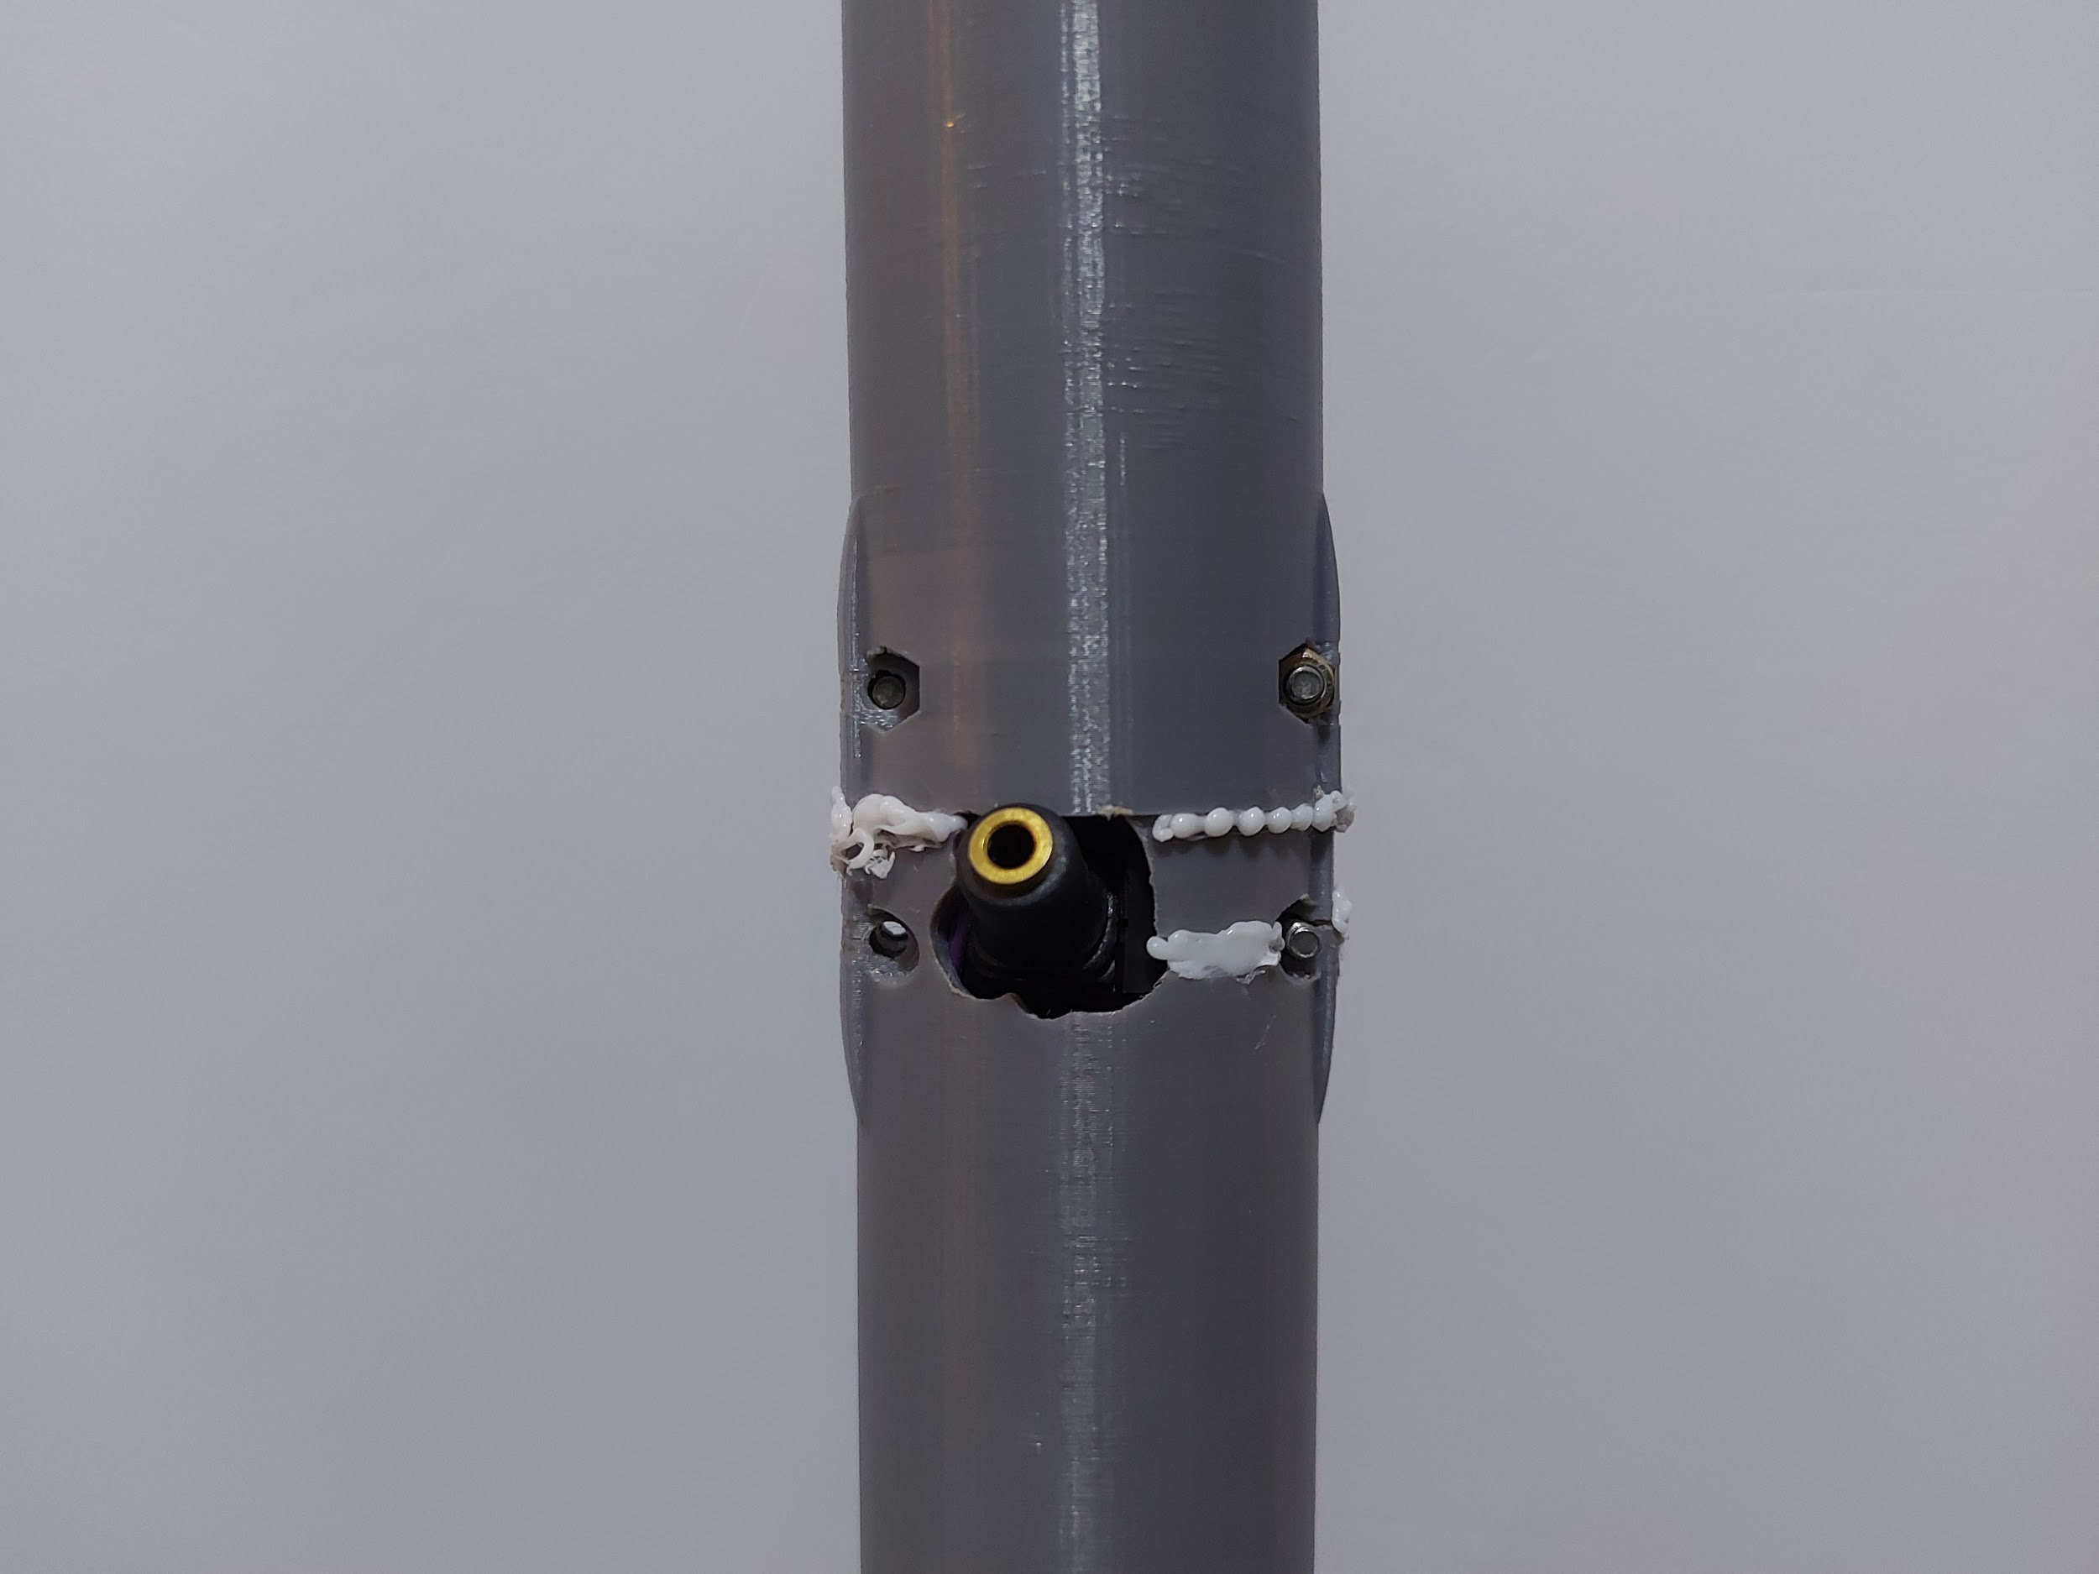

Audio Port

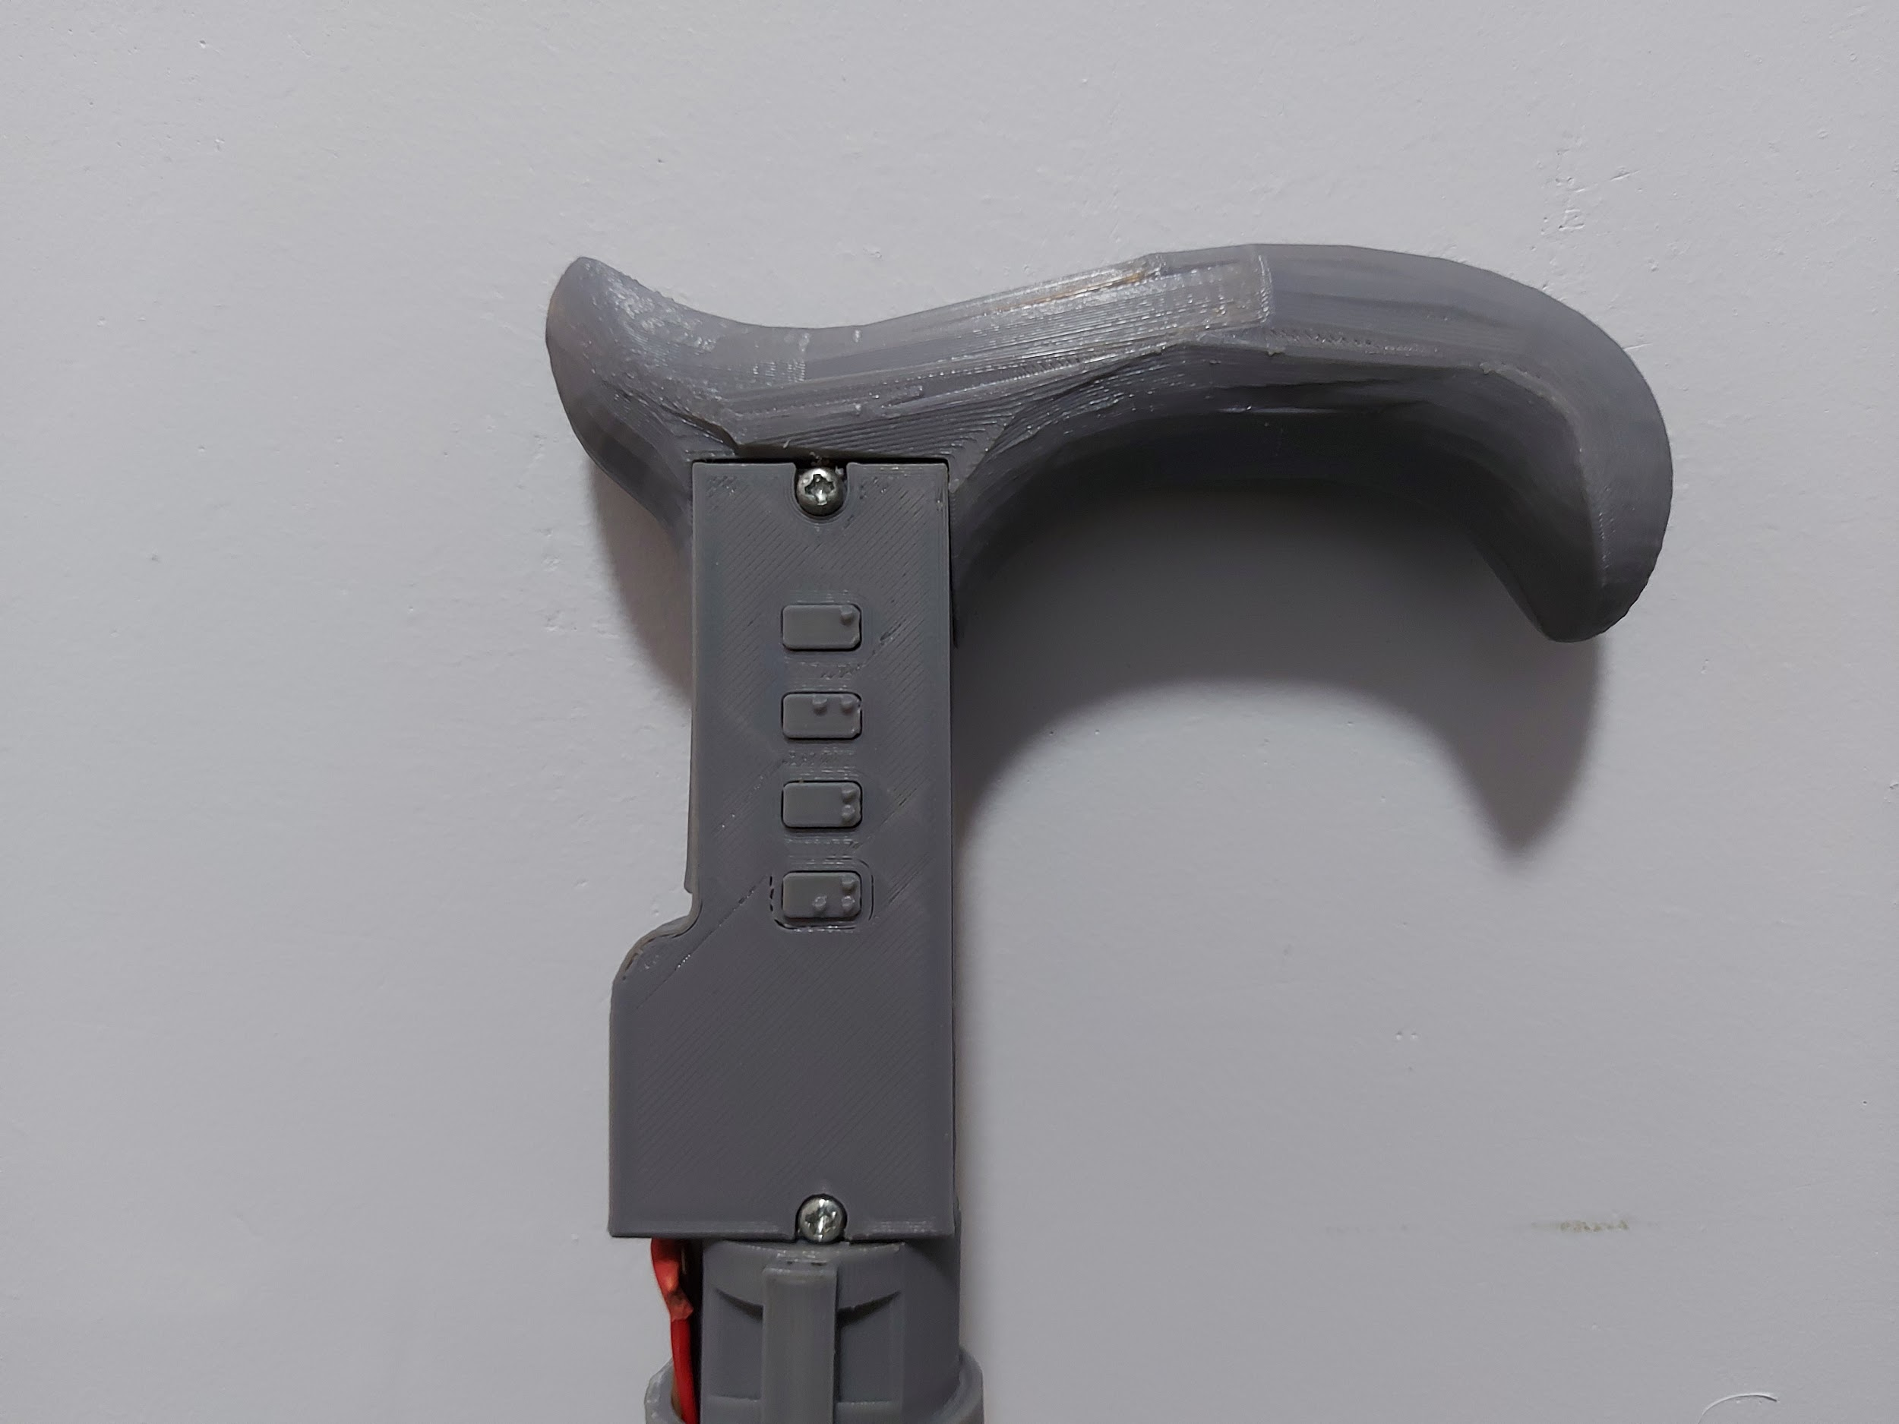

OK Button

NEXT Button

PREV Button

Cancel Button

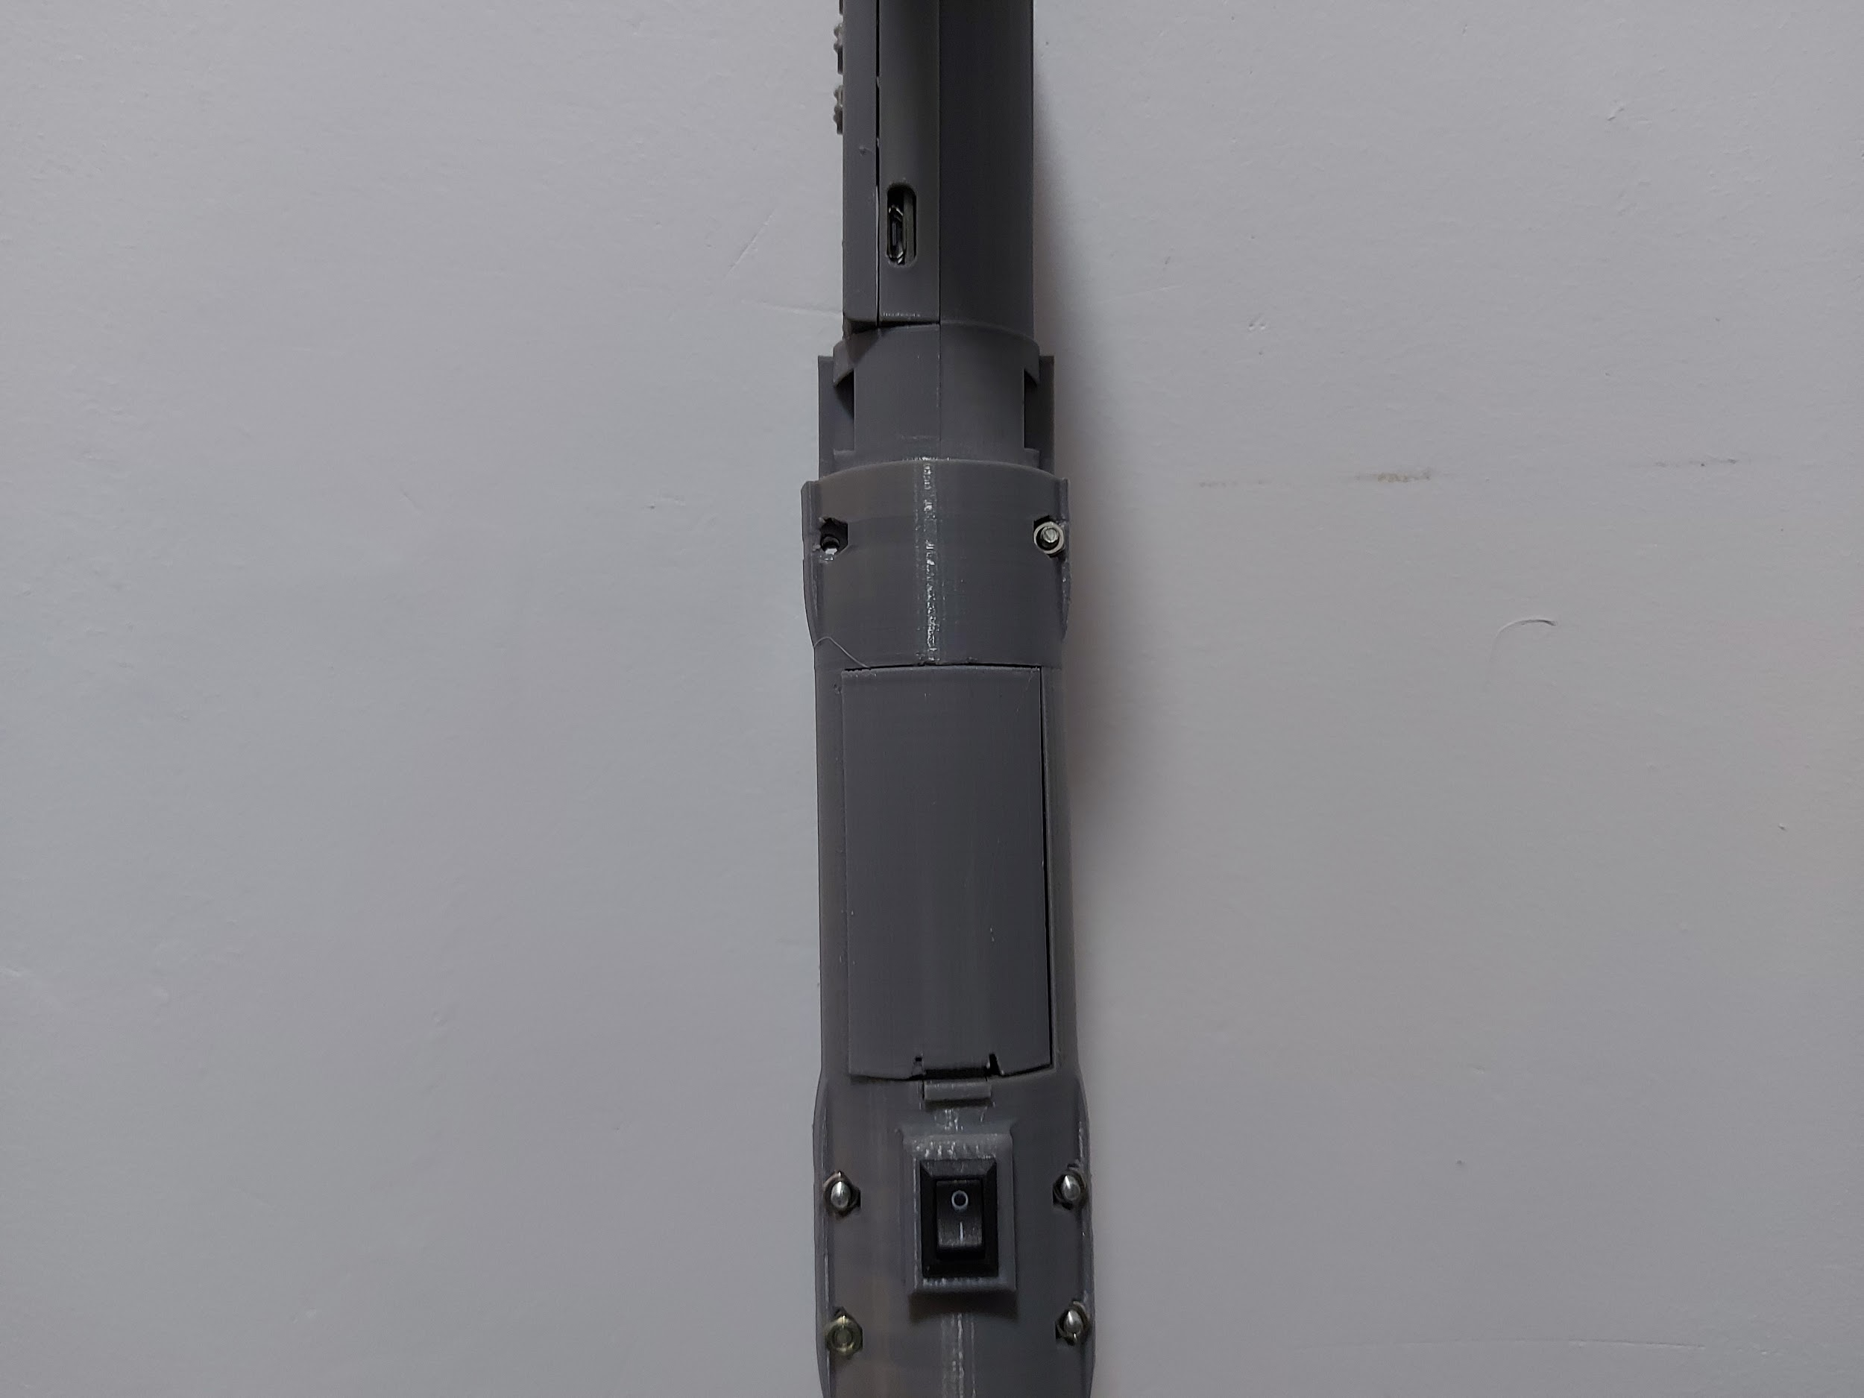

Switch

Battery Compartment

Charging Port

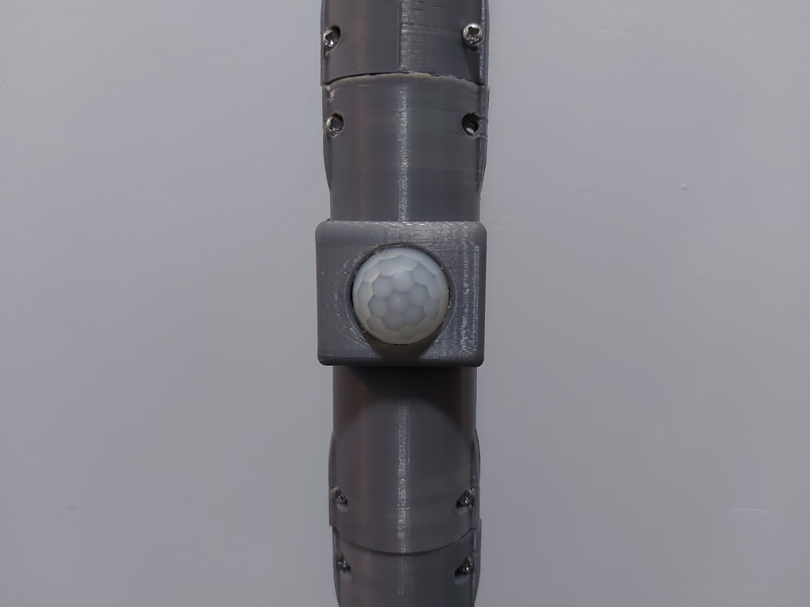

PIR Sensor

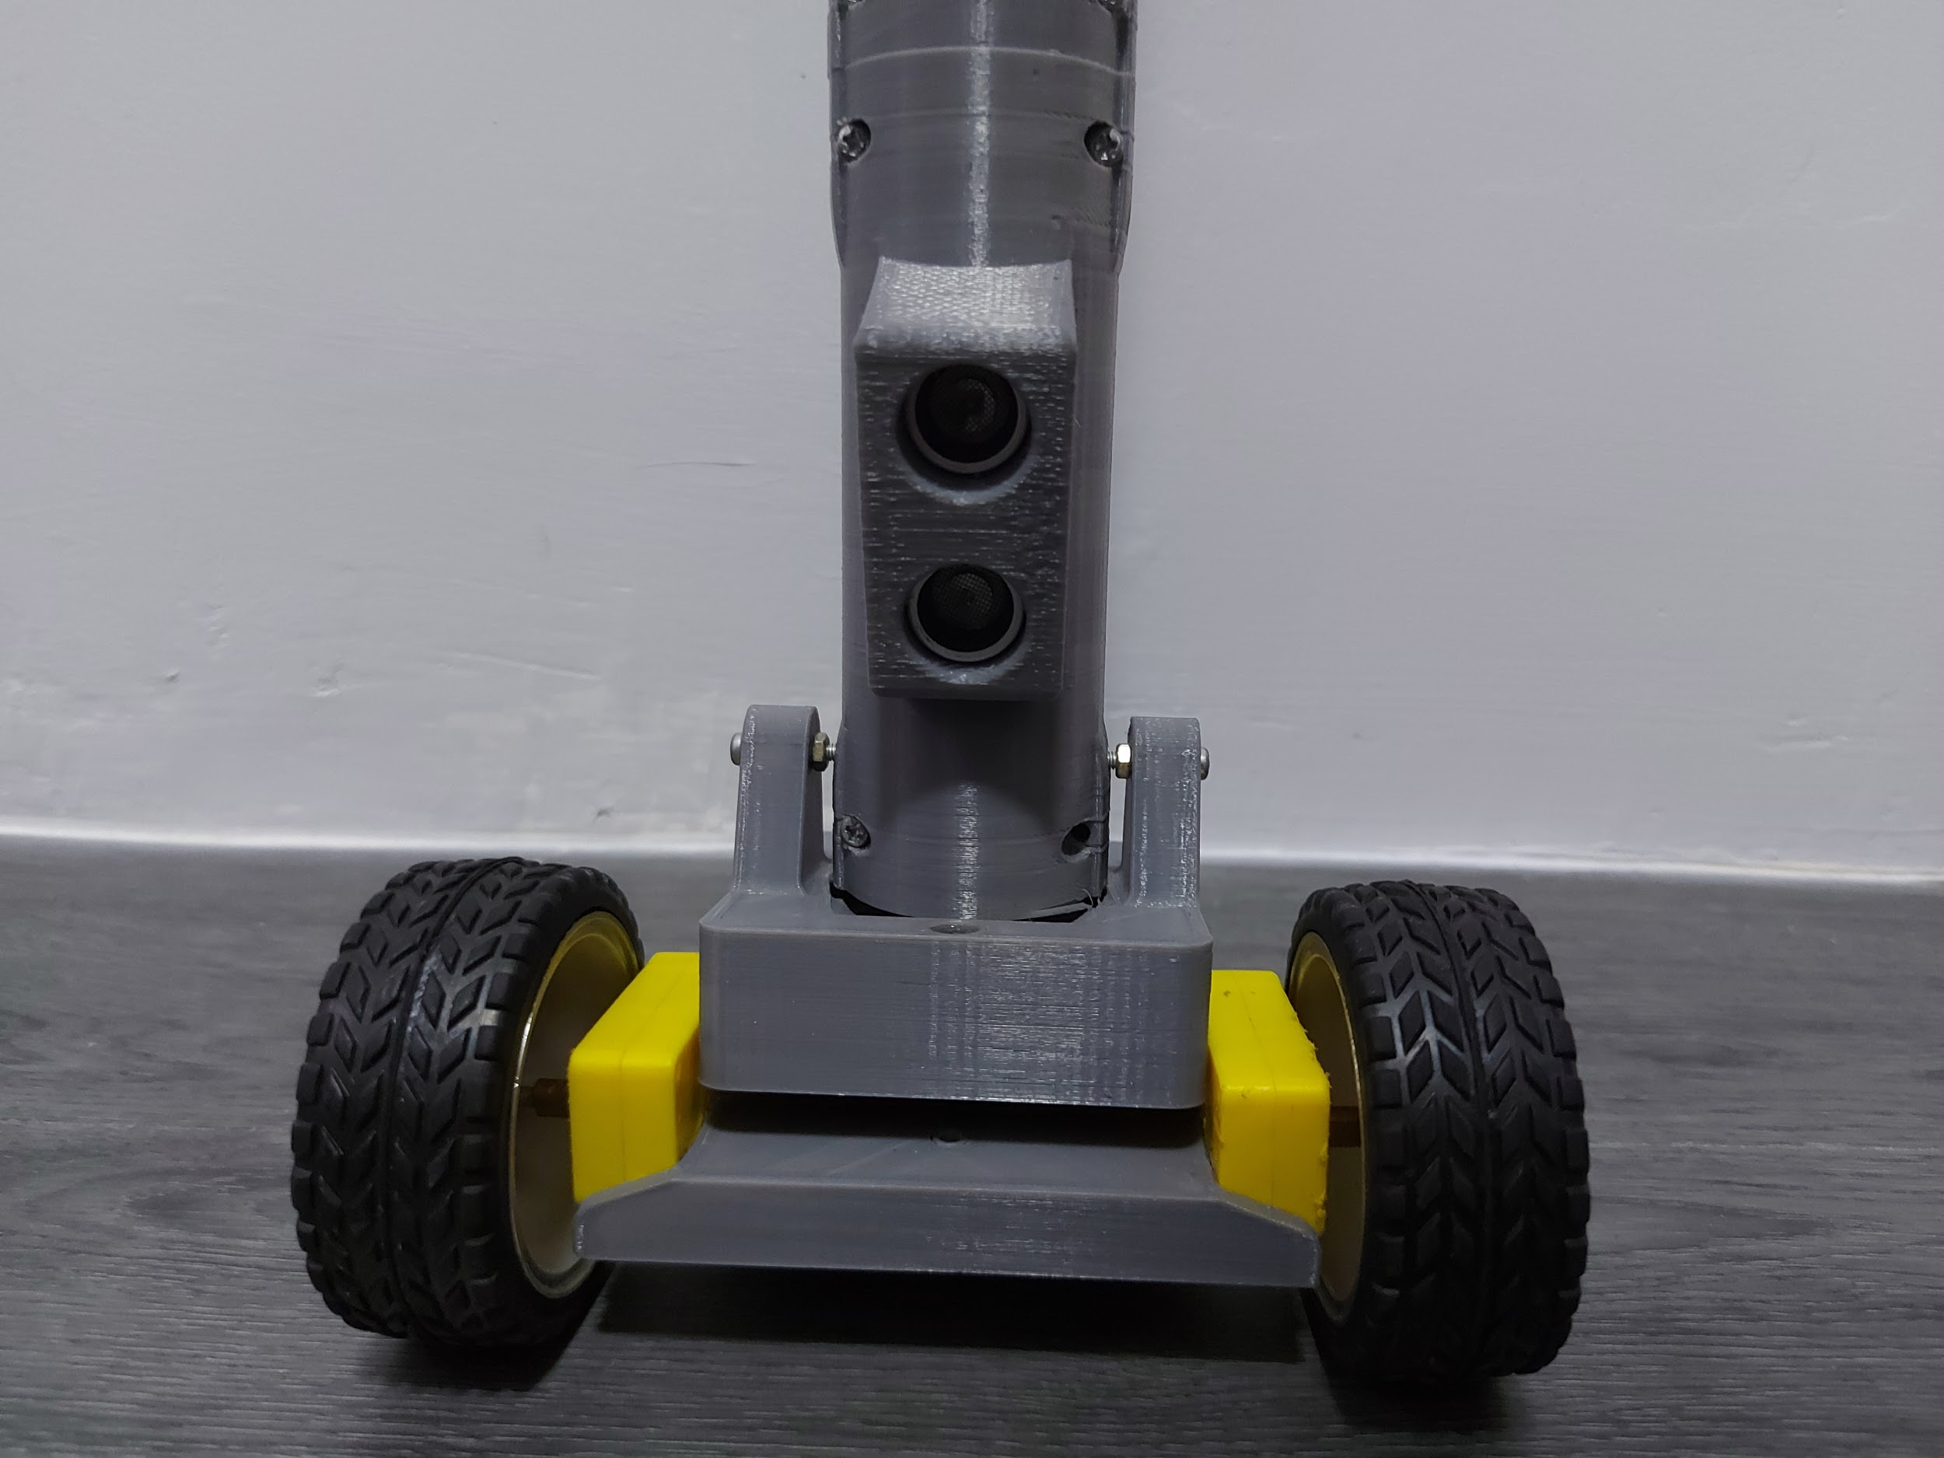

Ultrasonic sensor

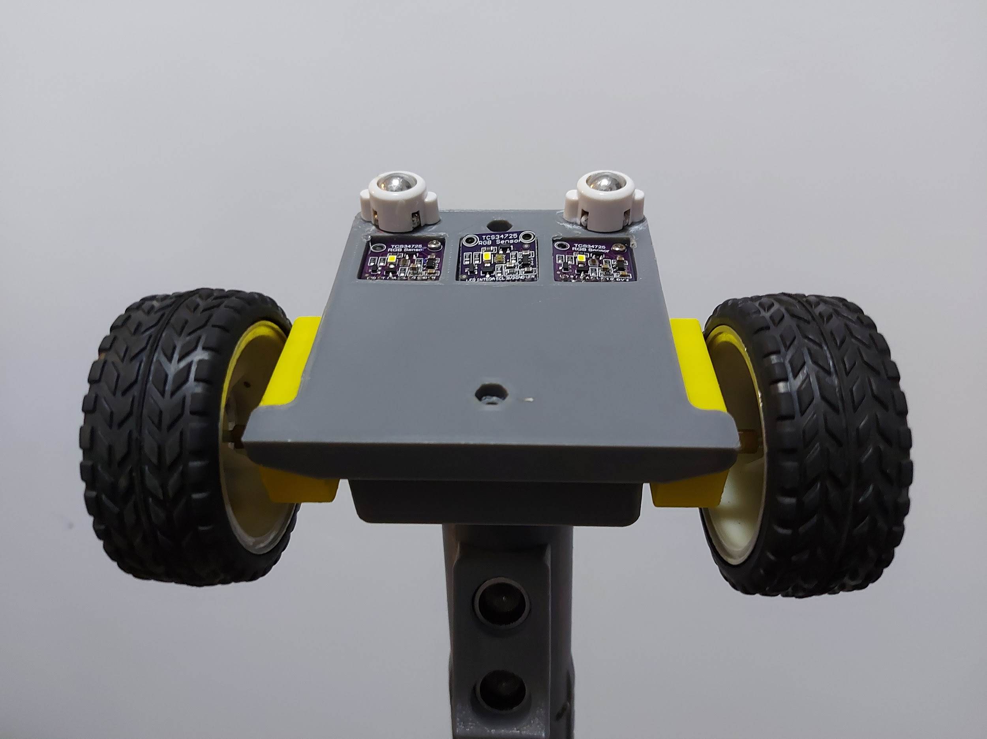

Color Sensors

**General:**

**Step 1:** Plug the earphones to the audio port

**Step 2:** Turn on the device by clicking the power switch. You should then be able to hear the starting up message through your earphone.

**Step 3:** Dictate your current location

**Step 4:** You should then be able to hear the next target location.

**Step 5:** After listening to the given target location, press the OK button to proceed to the given target location.

**Step 6:** After listening to the given target location, press the NEXT button for the next target location.

**Step 7:** After listening to the given location, press the PREV button for the previously given target location.

**Step 8:** Press the CANCEL button if you want to cancel.

**Step 9:** After the motor starts, the cane should be following its programmed pattern.

**Step 10:** If the cane detects an obstacle, the cane will stop, and the user will be notified through a voice message.

**Step 11:** If the cane has arrived at the target location, the cane will stop and the user will be notified through a voice message that they have arrived.

**Troubleshooting Guides and Procedures**

Through the course of the navigation, the device will encounter different scenarios that may cause interruptions to the process, such as not enough battery power. The following procedures are how to troubleshoot these scenarios:

Battery:

1. If the cane stops working, the device could either be low on battery or malfunctioning.
2. Checking and charging of batteries of the device needs the assistance of sighted people.
3. To change the batteries, unscrew the three screws with a screwdriver and remove the batteries from the battery holder.
4. To charge the batteries, attach the cord to the charging port of the cane and plug it to the outlet. Charge it for approximately 4 hours for it to be used again.
5. After charging the cane, check if it is now working properly by turning on the device. If it is still not working, the device might have a malfunctioning component, so it is advised to ask assistance from the device manufacturer.

**Error Definition**

The device will not run if an error is encountered. If the device is not running, even if restarted or turned on, the sensor must be detecting that the battery is low or the sensor must not be detecting the colored-lines, make sure the button sensor of the cane is placed above the colored-lines.

**Appendix C: Picture of Prototype**

**Back View**

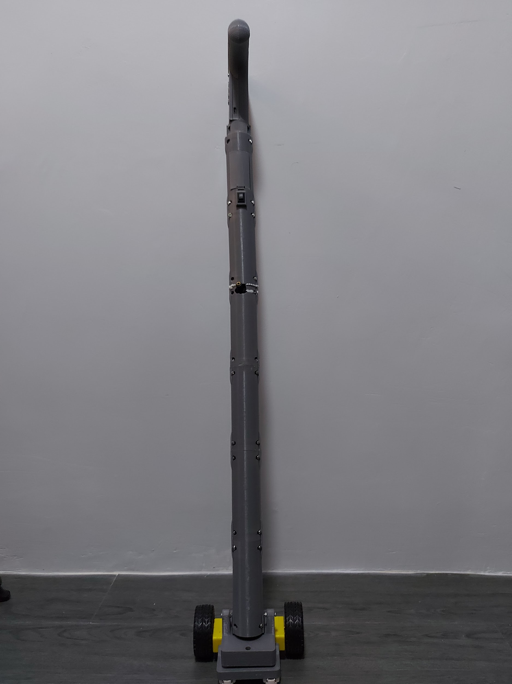

**Front View**

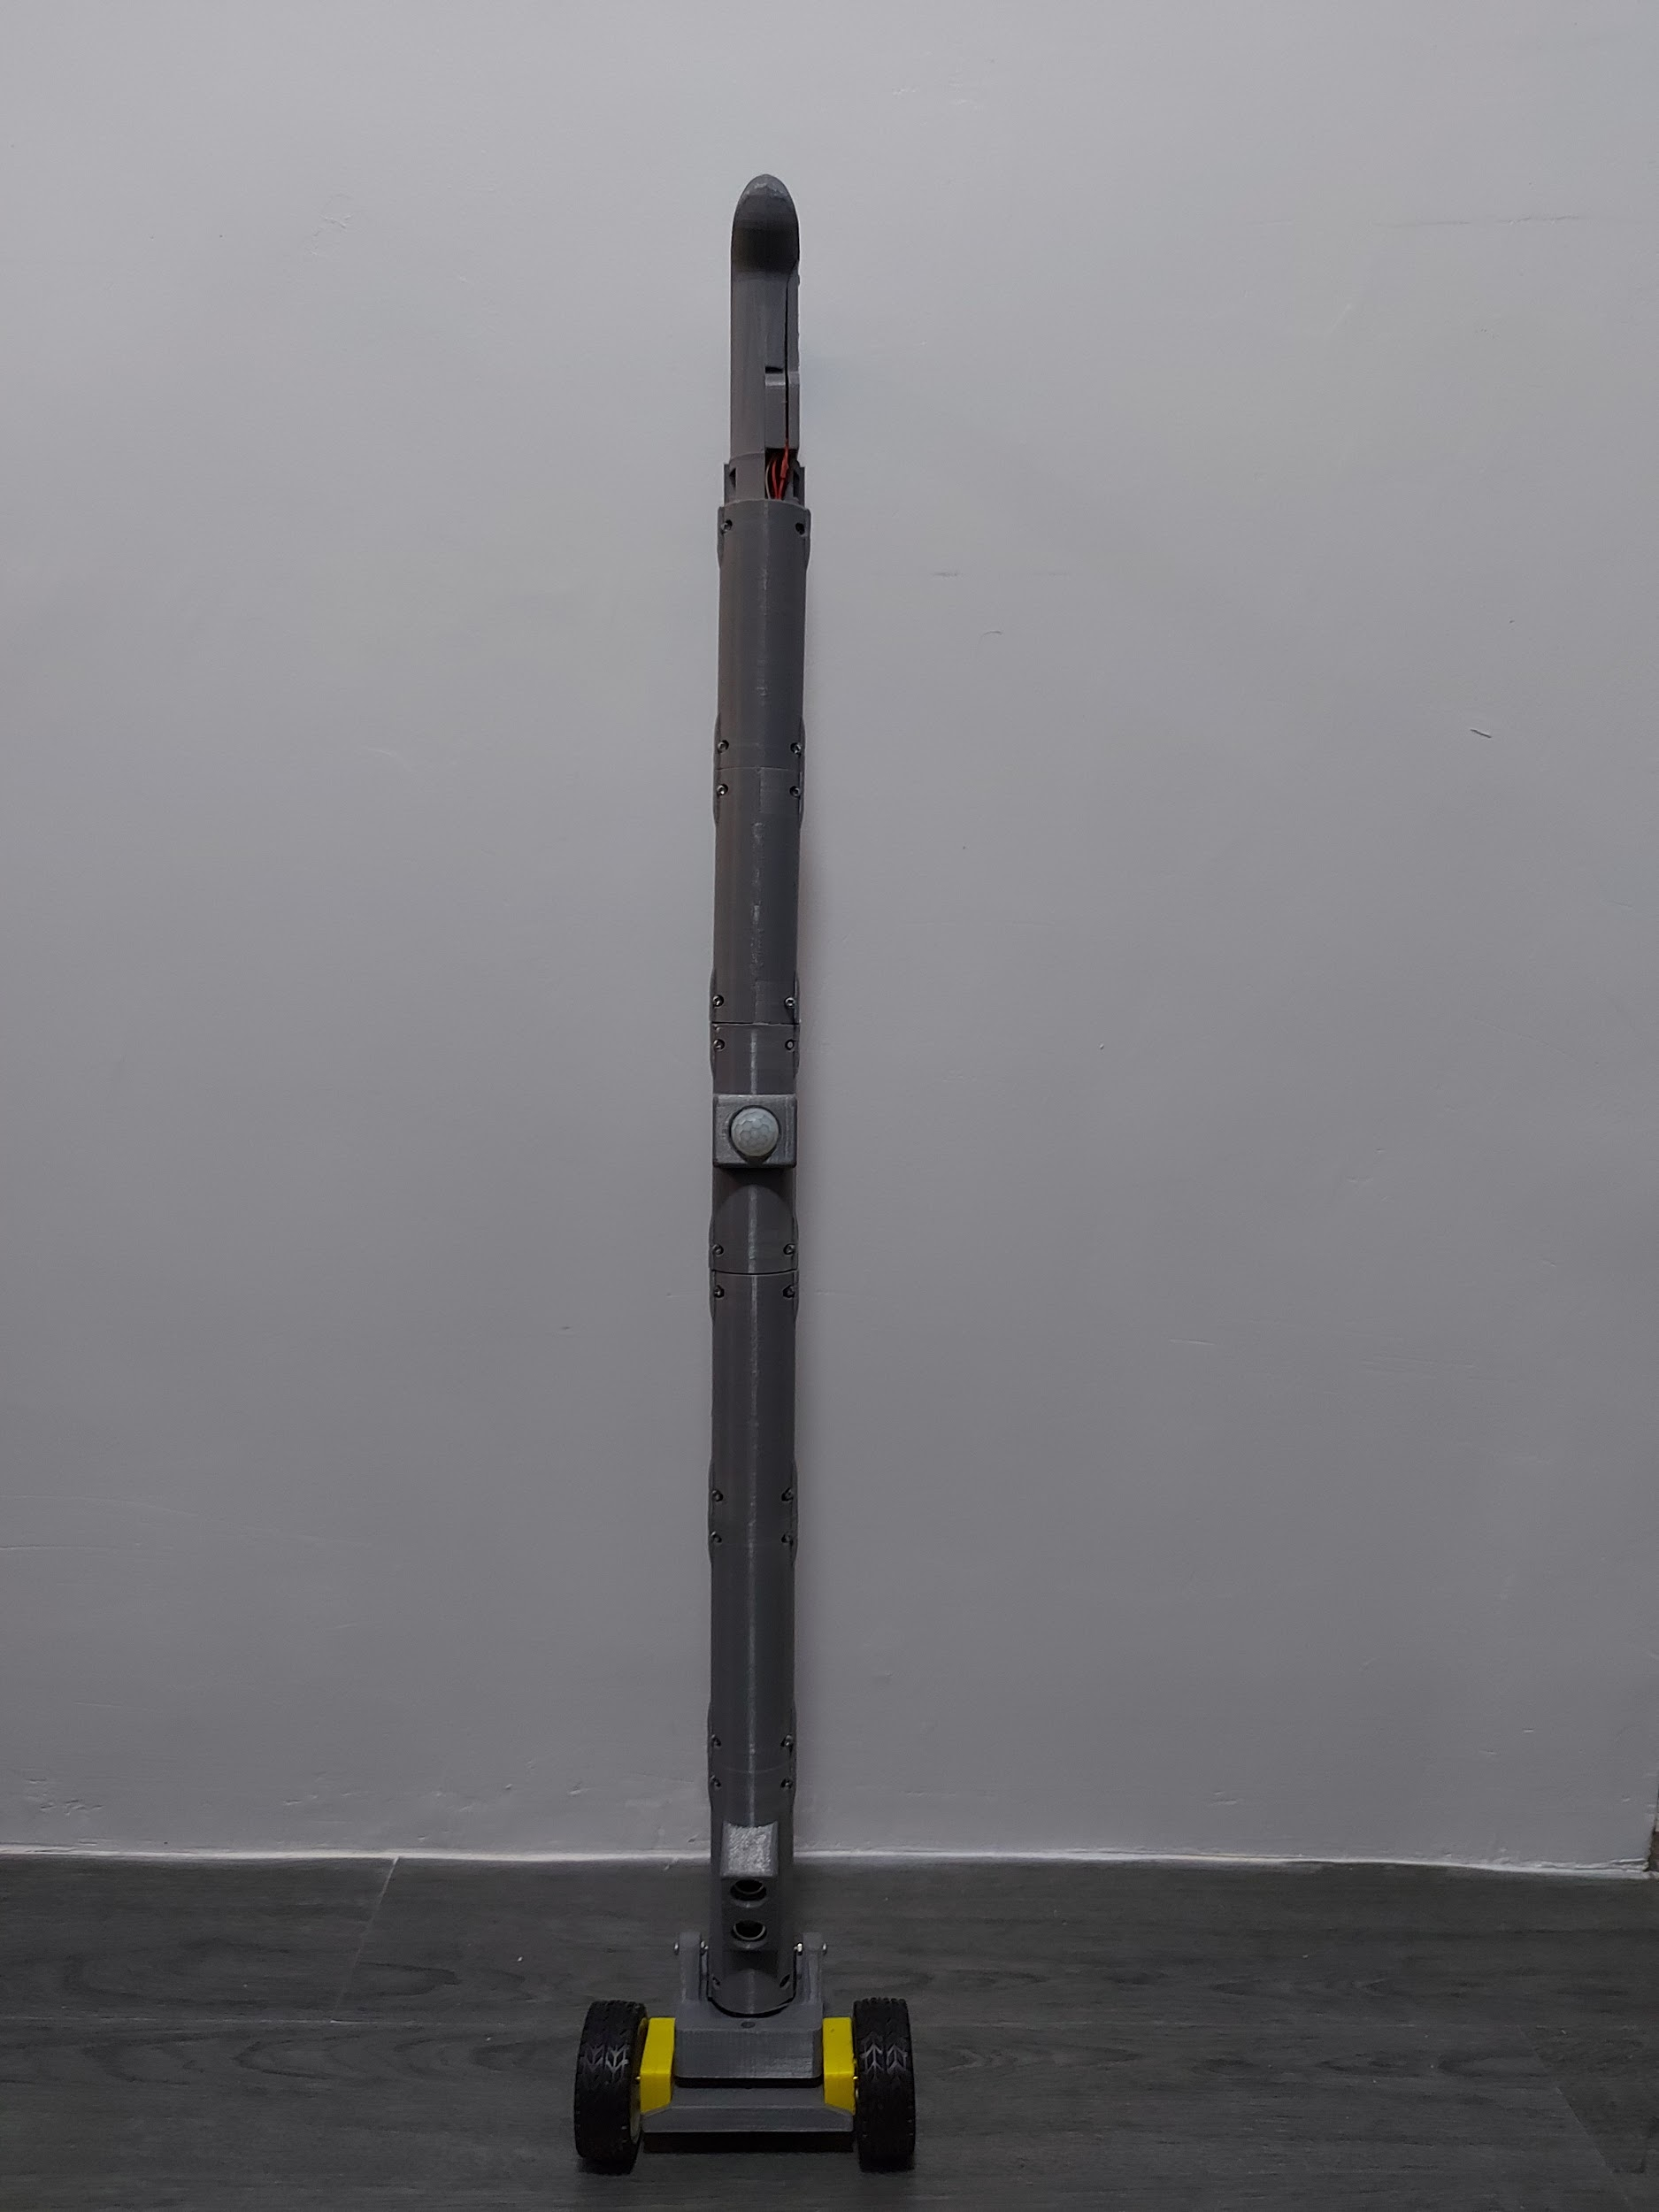

**Right View**

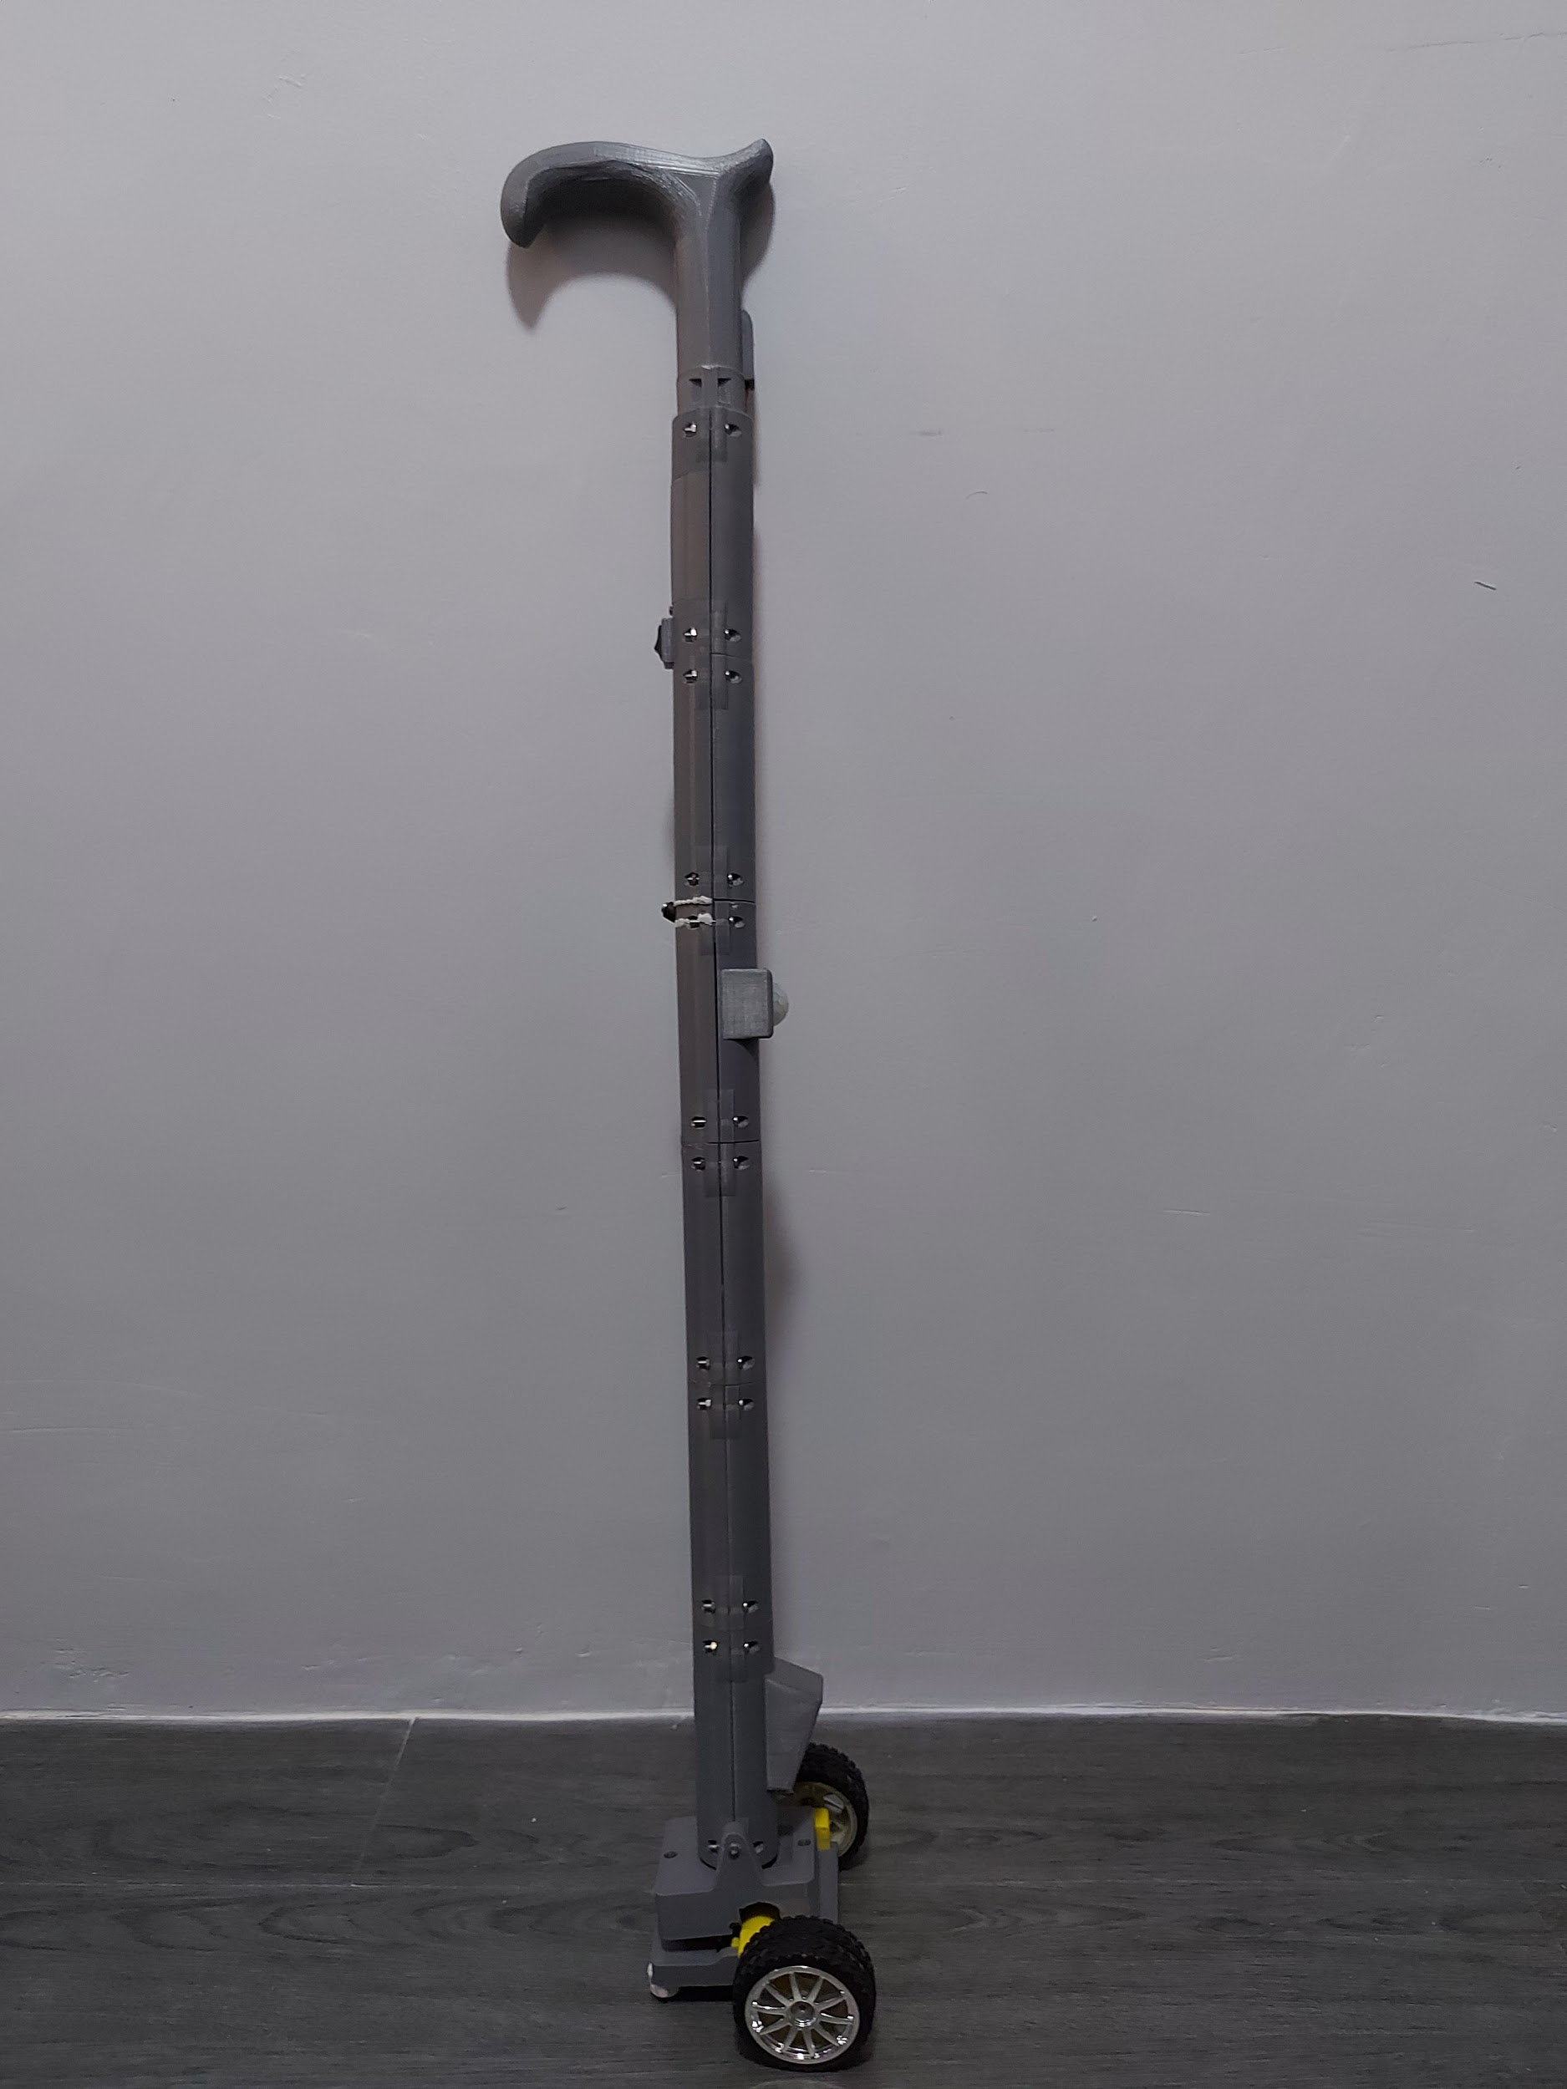

**Left View**

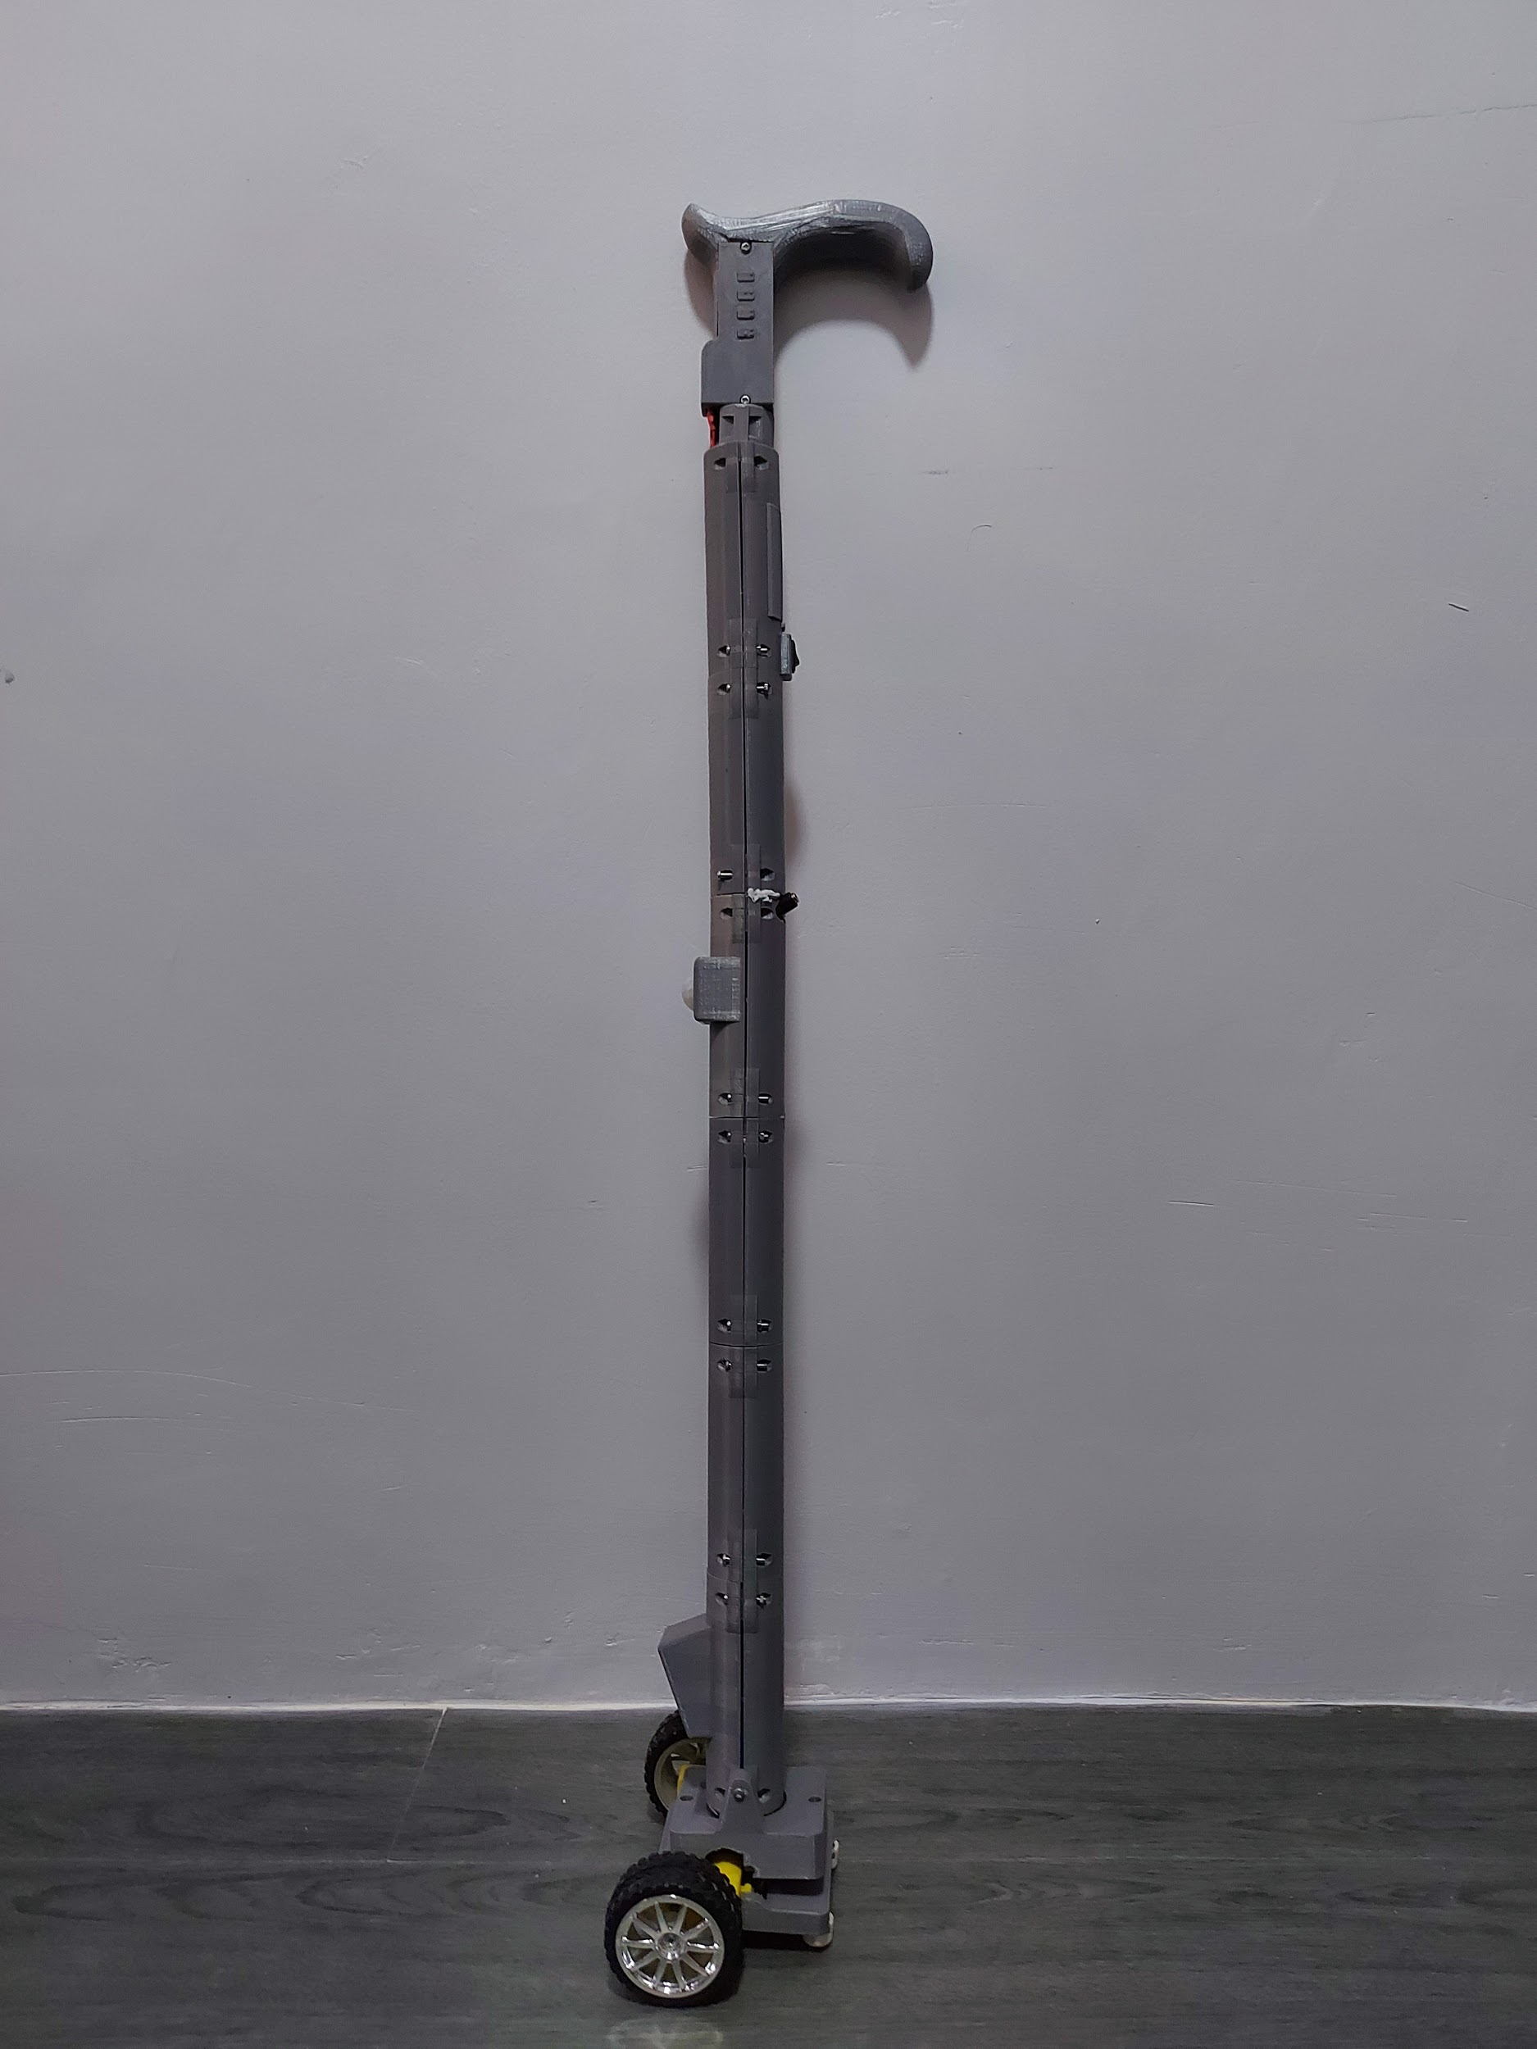

**Appendix D: Data Sheets**

* **ATmega328P**

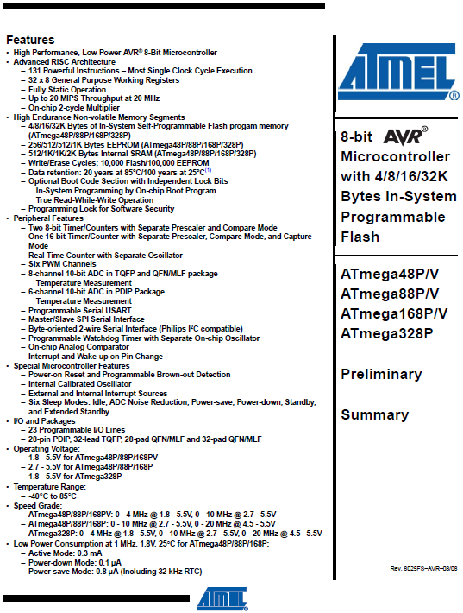

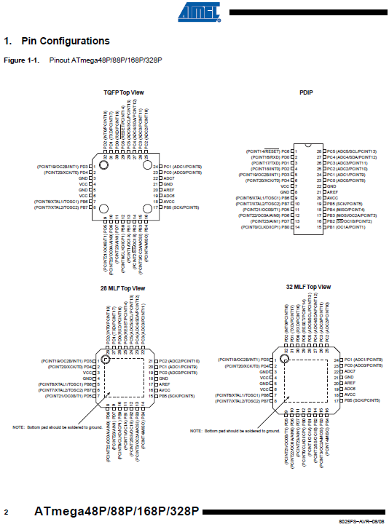

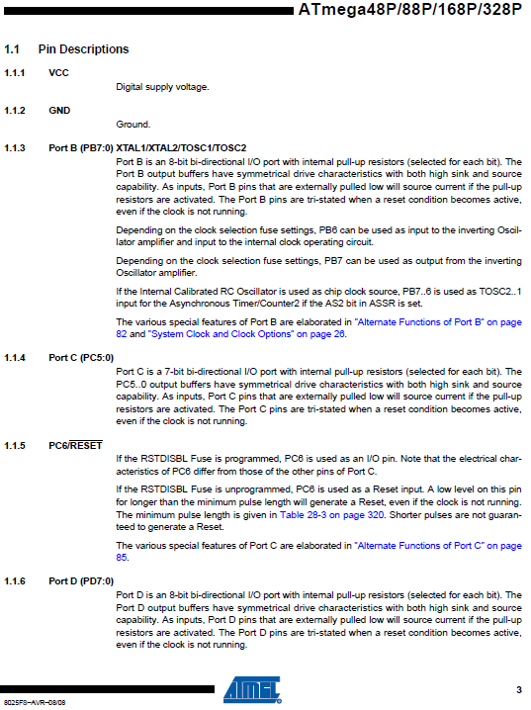

* **TCS34725 Color Sensor**

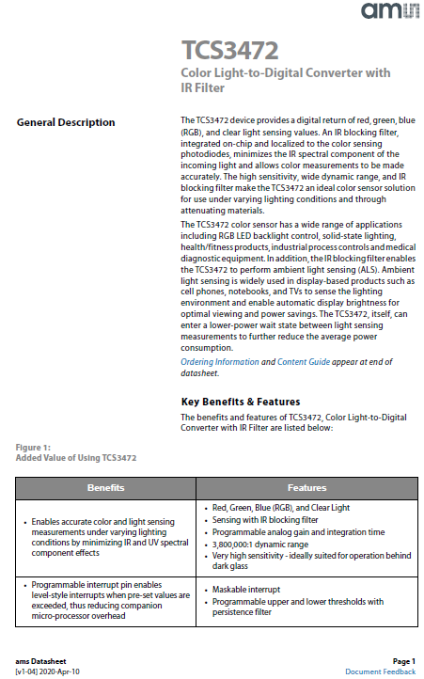

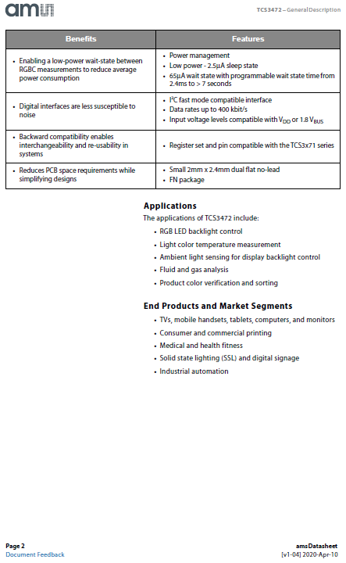

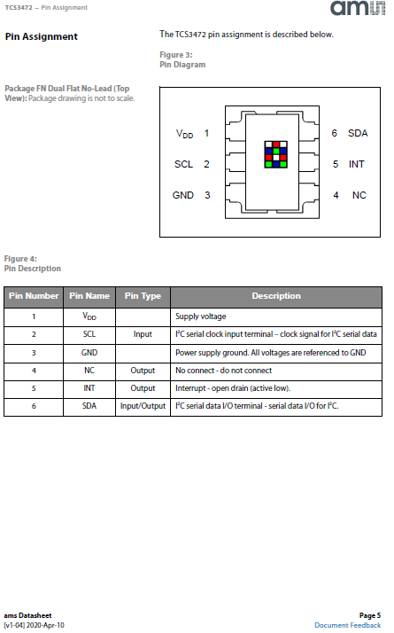

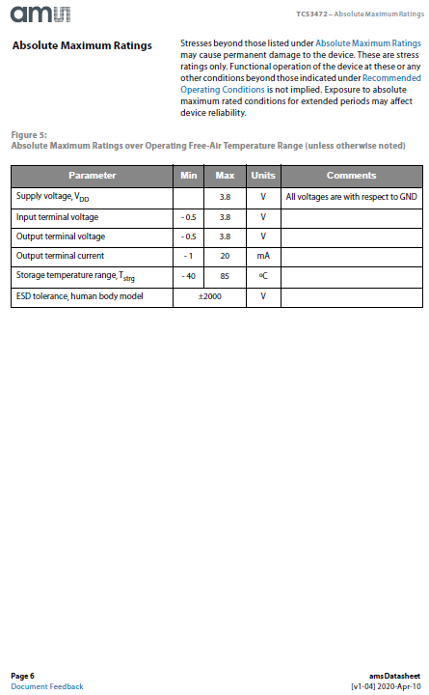

* **L293D motor driver**

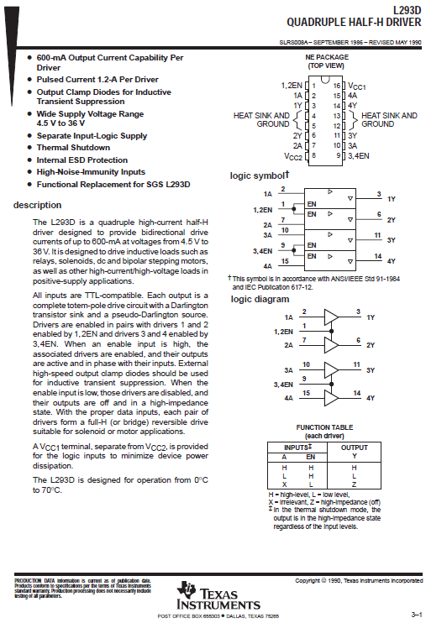

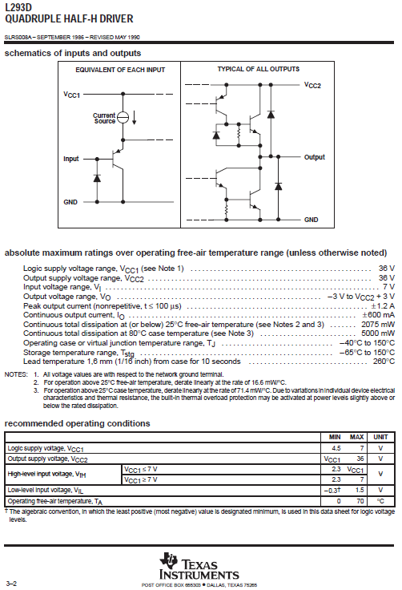

* **Ultrasonic Sensor SR-04**

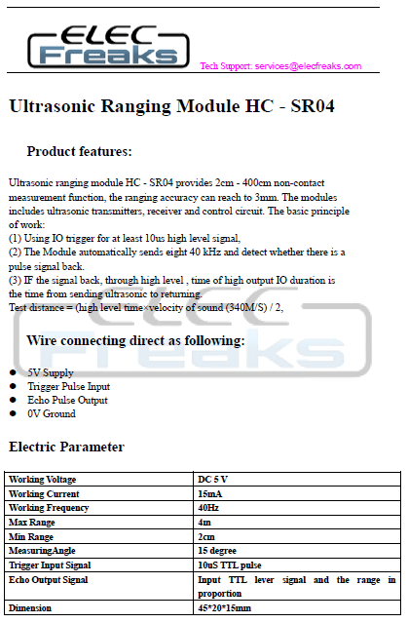

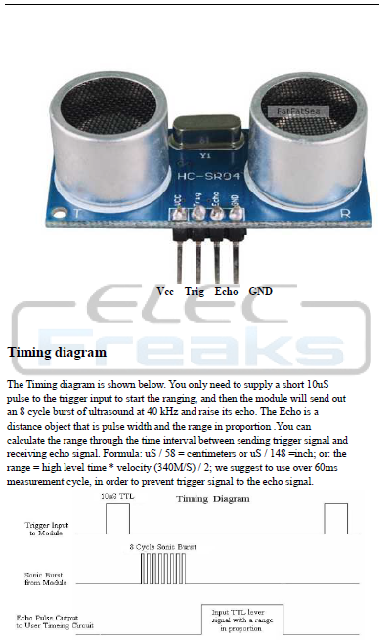

* **PIR sensor**

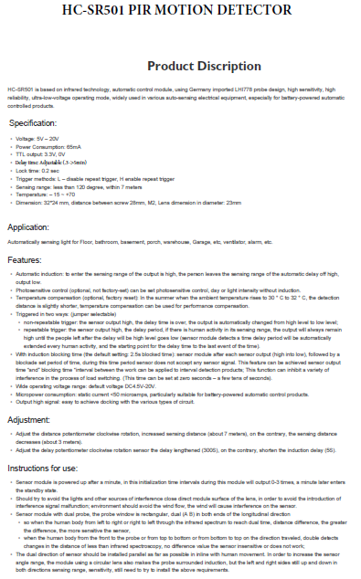

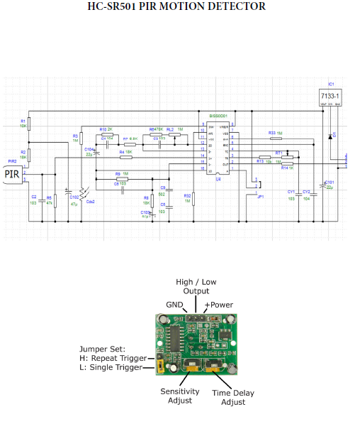

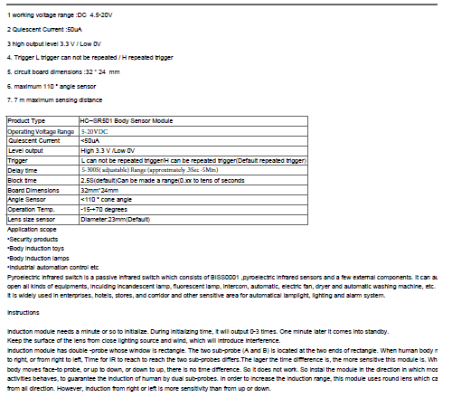

* **DF mini player**

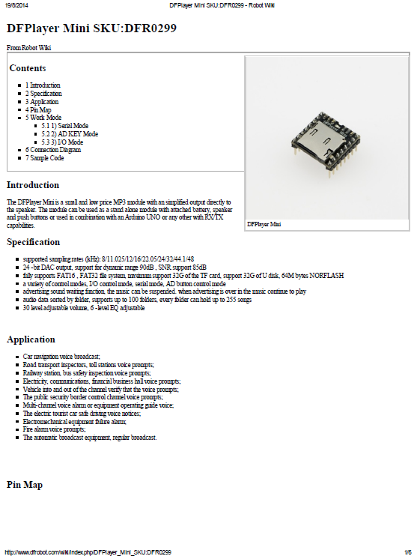

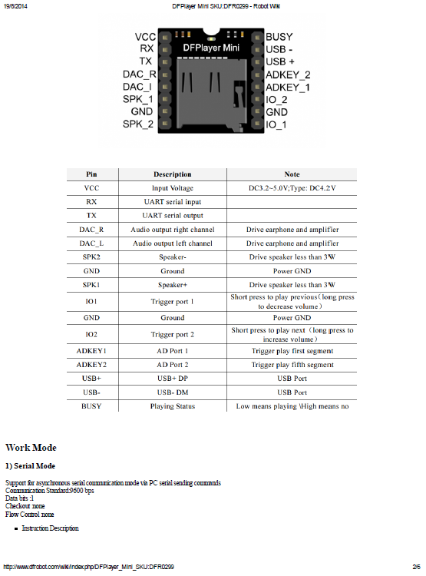

* **PAM8403**

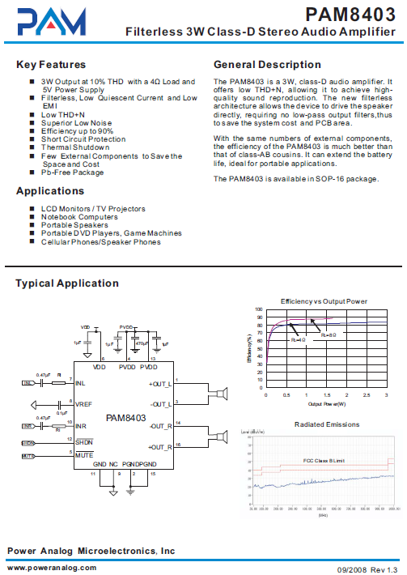

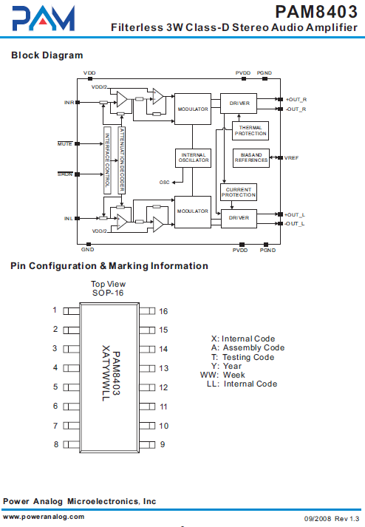

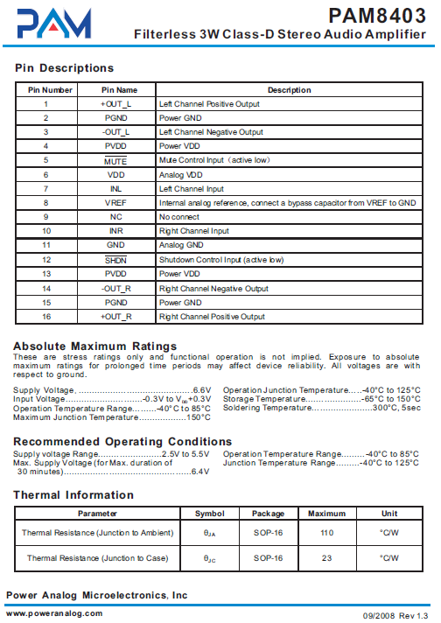

* **Rocker switch**

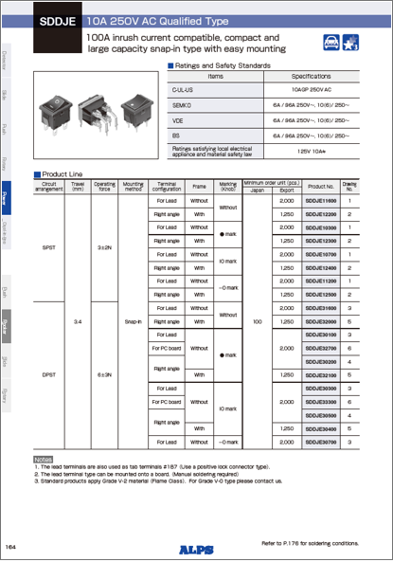

* **Push button**